### 

Programming

1 Year – 1 SEM

2023-2024

Pearson HND in Computing (Level 4)

Najwa Mohammed Islam

Dr. Samaa Mukhaimar

Table of Contents

How did this story called “algorithms” begin? 3

What is an Algorithm? 4

How do you think algorithms works 6

Features of an algorithm 7

What is a Flowchart? 9

**Historical Perspective** 9

**Visual Representation** 9

Defining the Flowchart 10

**Basic Components** 10

**Flowchart Symbols** 11

Let’s see what the types of algorithms and their uses are 13

**Types of Algorithms:** 13

How computer understand programming 18

Defining Programming Paradigms 19

Types of Programming Paradigms 20

**1.** **Procedural Programming Paradigm** 20

**2.** **Object-Oriented Programming (OOP)** 24

Relationship between Programming Paradigms 33

**Relationship between Procedural and Object-Oriented Programming** 33

**Relationship between Event-Driven and Object-Oriented Programming** 33

Software Development Life Cycle (SDLC) 34

**What is it SDLC?** 34

**Deciphering the Stages of SDLC** 34

Integrated Development Environment (IDE) 61

**Definition of IDE** 61

**Significance of IDE in the Programming World** 61

Debugging 64

**Understanding the Debugging Process** 64

**Launching and Debugging a Java Program** 64

Coding Standards 67

**Understanding Coding Standards** 67

**Why Coding Standards Matter** 67

Algorithms were created by humans, supervised by humans, and fed with information by humans. Like any other innovation, they are able to play an important role in the development of humanity and move it to another level of progress and prosperity.

There is no doubt that learning algorithms is one of the important pieces of advice given to you if you decide to learn programming. The word algorithm is often used in the field of programming and other fields such as mathematics, science, logic, and everything related to computers in particular. It is one of the most important concepts without which you cannot learn programming, mathematics, and computer science.

How did this story called “algorithms” begin?

An "algorithm" is a set of mathematical, logical, and sequential steps necessary to solve a problem. The algorithm was named after the scientist Abu Jaafar Muhammad bin Musa Al-Khwarizmi, who was the first to invent it in the ninth century AD. The word widespread in Latin and European languages ​​is “algorithm,” and originally its meaning was limited to an algorithm for only three structures: sequence, selection, and repetition.[1]

3

What is an Algorithm?

An algorithm is more than a set of instructions; it's a well-defined, step-by-step, logical procedure for solving a given problem. It provides abstract steps for processing one sequence of related information into a different sequence of derived information. The beauty lies in its accessibility, as it can be expressed in plain English, flow charts, pseudo code, and various programming languages. Surprisingly, an algorithm can even be executed by a person.[1]

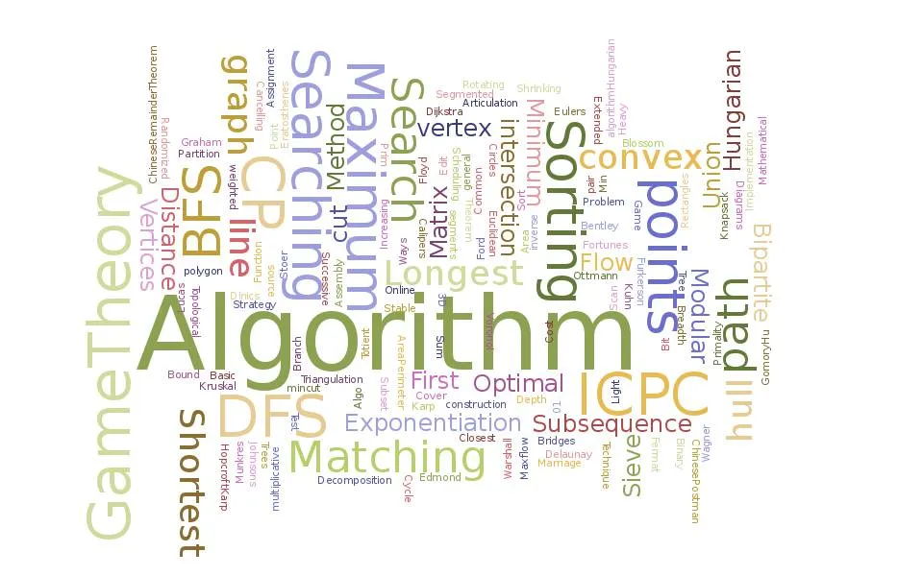**Algorithm in Detail**

The intricacies of algorithms involve a meticulous step-by-step logical procedure, processing a sequence of related information, and allowing accessibility to those from non-programming backgrounds. Whether represented in natural language, flow charts, or pseudo code, an algorithm stands as a versatile tool for problem-solving.[2]

Fig.1. Algorithm

**What is a Program?**

A program, on the other hand, refers to a set of instructions for a computer to follow. It can implement many algorithms or none at all. The constituents of a program may not be conceptually related, and it can be written in any programming language, such as Python, Java, C++, or any other language, depending on the task at hand. The pivotal point is that a program is always executed by a computer.[2]

**Components of a Program**

Understanding a program involves grasping its conceptual relationships, the potential existence of unrelated elements, and the role of programming languages. The translation from human-readable code to machine-executable instructions is facilitated by a compiler or interpreter, making a program universally understandable by any computer system.

4

**Execution of a Program**

The execution of a program involves implementing it on a computer system, aided by a compiler or interpreter. The choice of programming languages contributes to the diversity of program execution methods. It emphasizes the symbiotic relationship between a program and the computer that executes it.

**Algorithm vs. Program: Key Differences**

Distinguishing between algorithms and programs is vital. While algorithms focus on abstract problem-solving procedures, programs translate these solutions into computer-executable instructions. We'll explore the distinct characteristics of each, shedding light on their unique aspects and practical examples.

**Algorithm in Real-world Applications**

Algorithms aren't confined to the digital realm; they shape our daily lives. From search engine algorithms to recommendation systems, their impact is undeniable. We'll explore algorithmic efficiency, optimization, and their role in addressing real-world problems.

**Program in Real-world Applications**

Transitioning from abstract concepts to tangible applications, we'll delve into real-life examples of computer programs. From automation to program-driven technologies, we'll examine how programming influences and shapes modern society.

5

**Choosing the Right Approach**

When faced with a problem, choosing between an algorithmic or programmatic approach is pivotal. Understanding when to employ algorithms and when to develop a full-fledged program is essential. We'll explore the considerations involved in decision-making and striking the right balance.

Algorithms and programs, while interconnected, serve distinct purposes. Recognizing their differences is key to navigating the ever-evolving landscape of computing. Whether you're a seasoned developer or a curious enthusiast, grasping these fundamentals enhances your problem-solving capabilities.

How do you think algorithms works

Computer algorithms work via input and output. They take inputs and apply each step of the algorithm to that information to generate an output. The entry leads to steps and questions that need to be addressed in order. When each section of the flowchart is completed, the result generated is the output.

**A component of an Algorithm;** an algorithm in computer science, is a series of explicit instructions that runs computer programs to do a variety of tasks. They can be designed to perform a simple action, such as subtracting two numbers, or more complex operations, such as finding the best path between two or more geographic locations. As such, computer algorithms are extremely useful for performing all types of tasks, from calculations and data processing to decision making.

Each algorithm consists of a fixed start and end point, producing outputs according to predefined inputs and steps. Multiple algorithms can be combined to perform more detailed tasks, but increasing complexity requires more computational resources.

6

**Do you know how algorithms are measured;** Algorithms are measured by their correctness and efficiency. Where correctness refers to the accuracy of the algorithm and whether it can solve a particular problem or not. Efficiency is related to the amount of resources and time an algorithm needs to perform a particular task. Many computer scientists use a mathematical analysis technique known as convergence to compare different algorithms, regardless of the programming language or hardware they are run on.

Bit coin’s proof-of-work algorithm, in the context of block chain, is a key component of the mining process – one that verifies and validates transactions, securing the network and ensuring that it is working as intended.

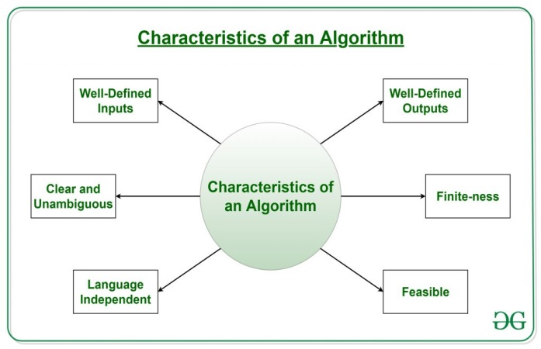

Features of an algorithm

Algorithms are the backbone of computer science. For an algorithm to be effective, it must possess specific features that guarantee its accuracy, predictability, and practicality. We’ll delve into the five essential features that define a robust algorithm.[3]

Fig.2. Features of an algorithm

Algorithms are like the unsung heroes of the digital world, silently powering various processes and applications. To understand what makes an algorithm truly effective, we need to explore the crucial features that ensure its functionality and reliability. Let's examine each of these traits individually.

Before diving into specifics, let's establish a clear definition of the characteristics that define algorithms. A solid foundation sets the stage for a robust algorithmic report.[3]

7

1. **Well-Defined Inputs**

At the core of every algorithm lies the need for well-defined inputs. Imagine trying to follow a recipe without clear measurements or ingredients—it's a recipe for disaster. Similarly, an algorithm's inputs must be precisely defined to ensure that it operates correctly and consistently.[3]

1. **Well-Defined Outputs**

Just as inputs must be clear, an algorithm's outputs should also be well-defined. This ensures that the algorithm consistently produces the intended and accurate result for a given set of inputs. It's about achieving the desired outcome with precision.[3]

1. **Unambiguity in Algorithms**

Ambiguity and algorithms are a volatile mix. Any vagueness or uncertainty in an algorithm's description can lead to incorrect implementations and unreliable results. Clarity is key to avoiding pitfalls in the code maze.[3]

1. **Finiteness of Algorithms**

An algorithm should have an expiration date—it should terminate after a finite amount of time. Imagine an algorithm that runs endlessly, consuming resources without ever reaching a conclusion. Finiteness is about setting boundaries, ensuring efficiency, and preventing infinite loops.

1. **Effectiveness and Feasibility**

Feasibility is the litmus test for an algorithm's practicality. It should be effective in solving the problem at hand and feasible within reasonable constraints and resources. An algorithm may be brilliant in theory, but if it's impractical, it serves little purpose.

8

1. **Celebrating Independence**

The universality of algorithmic instructions is celebrated in this section. Independence ensures that algorithms can be implemented across various programming languages, fostering versatility.

Consequently, these are the qualities that a fruitful algorithm should possess.

Flowcharts have become indispensable tools for visualizing processes and systems in various fields. They offer a clear and concise way to represent complex information, making them valuable assets in communication and problem-solving. In this article, we will delve into the world of flowcharts, exploring their definition, significance, and the symbols that bring them to life.

What is a Flowchart?

**Historical Perspective**

Flowcharts have a rich history dating back to the early 20th century. They emerged as a visual representation of processes, allowing individuals to understand complex systems with ease. Today, flowcharts are ubiquitous in industries ranging from business to engineering.[4]

**Visual Representation**

At its core, a flowchart is a visual representation of a process or system. It uses standardized symbols to illustrate the flow of information, decision points, and the sequence of tasks. This visual clarity makes it an invaluable tool for conveying complex concepts in a straightforward manner.

9

**Common Uses**

Flowcharts find applications in various fields, including business, education, engineering, and project management. They are employed to document processes, analyze workflows, and facilitate efficient decision-making. The versatility of flowcharts makes them an essential part of organizational strategies.

Defining the Flowchart

**Basic Components**

A typical flowchart consists of various components, each serving a specific purpose. These include the start/end symbol, process symbol, decision symbol, and input/output symbol. Understanding these components is crucial for creating coherent and effective flowcharts.[4]



Flowcharts come in different types, catering to specific needs. Process flowcharts detail the steps of a process, while swim lane flowcharts organize information based on responsibilities. Understanding the type of flowchart required is essential for conveying information accurately.

Fig.3. Flowchart Symbols

10

**Flowchart Symbols**

Flowchart symbols act as the building blocks of the diagram. The start/end symbol denotes the beginning or end of a process, the process symbol represents a task, the decision symbol indicates a branching point, and the input/output symbol signifies data input or output.

Flowcharts use standardized symbols to convey information. Understanding these symbols is crucial for interpreting the content. Here are key symbols used in flowcharts: [4]

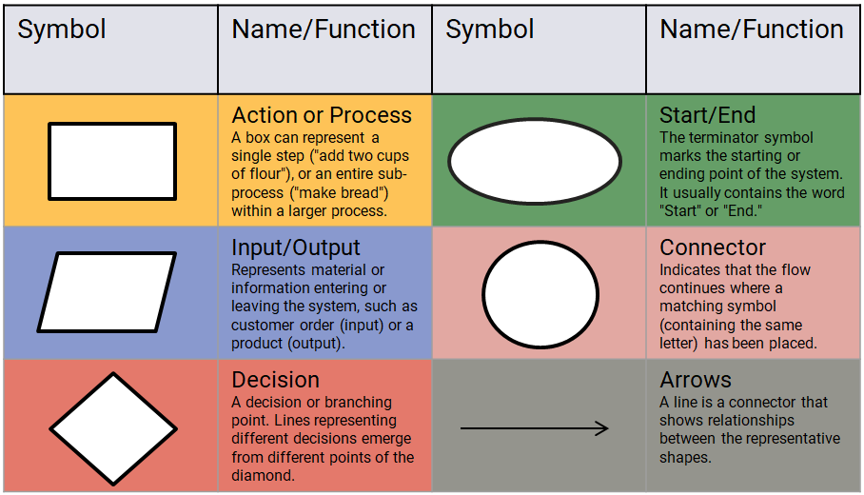

* **Action or Process Symbol**

The rectangular symbol represents actions or processes within the flowchart. Each rectangle describes a specific task or action in the overall process.

11

* **Input/output Symbol**

The parallelogram shape denotes input or output of data. It highlights points in the process where information is entered or produced as a result.

* **Decision Symbol**

The diamond shape signifies decision points in the process. Choices made at these points determine the flow of the chart.

* **Start/End Symbol**

The oval shape marks the beginning and end of the flowchart, indicating where the process starts and concludes.

* **Connector**

The circle symbol, labeled with a letter or number, shows continuity in the flowchart, useful for complex processes.

* **Arrows**

Arrows indicate the direction of the flow, guiding users through the logical progression of the depicted system.

Understanding these symbols empowers individuals to interpret flowcharts effectively, facilitating better communication and decision-making in various professional settings.

12

Let’s see what the types of algorithms and their uses are

Due to the different problems and the multiple ways to solve them, there are many different types of algorithms that are classified according to several factors, such as their classification according to the method of implementation, the method of improvement, or the degree of complexity. Below we mention some types of algorithms classified according to the design method and construction principle:[5]

**Types of Algorithms:**

1. **Sorting Algorithms**

Sorting algorithms are designed to arrange elements in a specific order, typically ascending or descending. Some common sorting algorithms include:

* **Bubble Sort**

Bubble Sort is a simple sorting algorithm that repeatedly steps through the list, compares adjacent elements, and swaps them if they are in the wrong order. The pass through the list is repeated until no swaps are needed, indicating that the list is sorted.

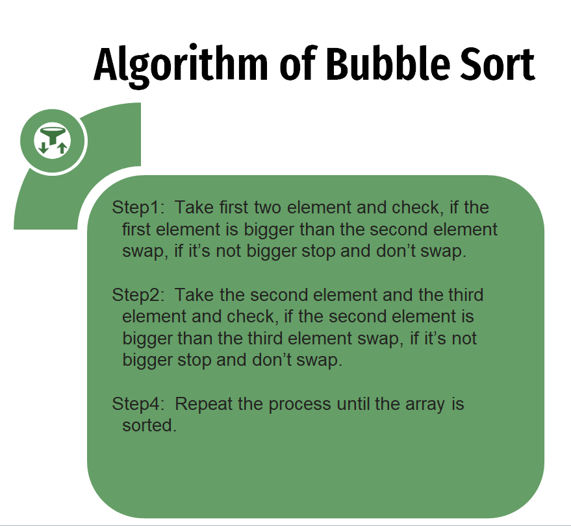

13

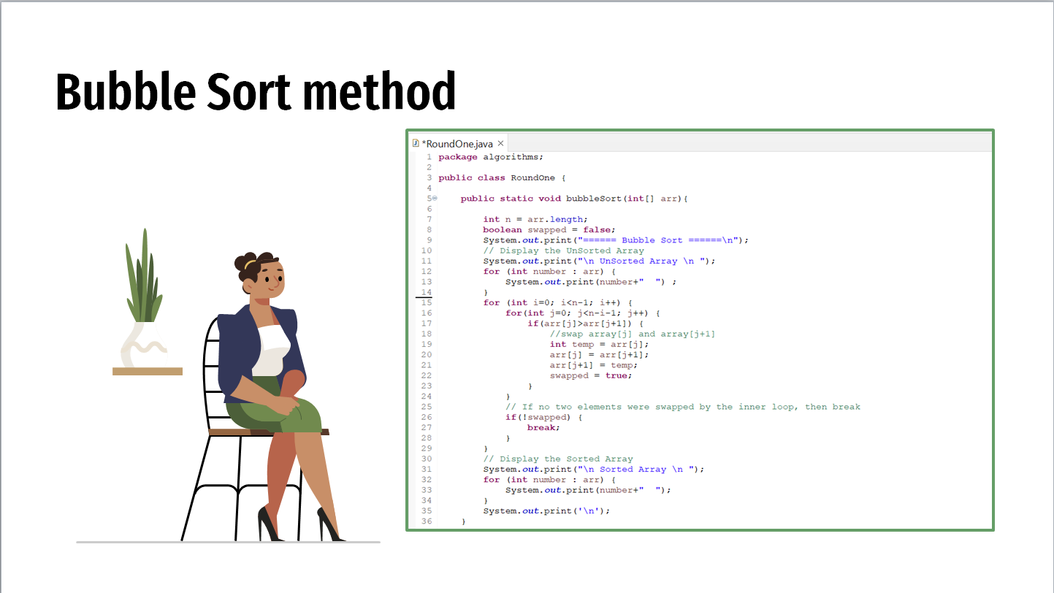

* **Selection Sort**

Selection Sort is another straightforward sorting algorithm. It works by dividing the input list into a sorted and an unsorted region. The algorithm repeatedly selects the smallest (or largest, depending on the order) element from the unsorted region and swaps it with the first element of the unsorted region.

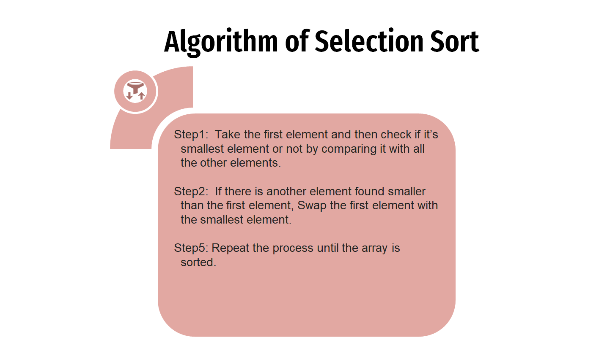

14

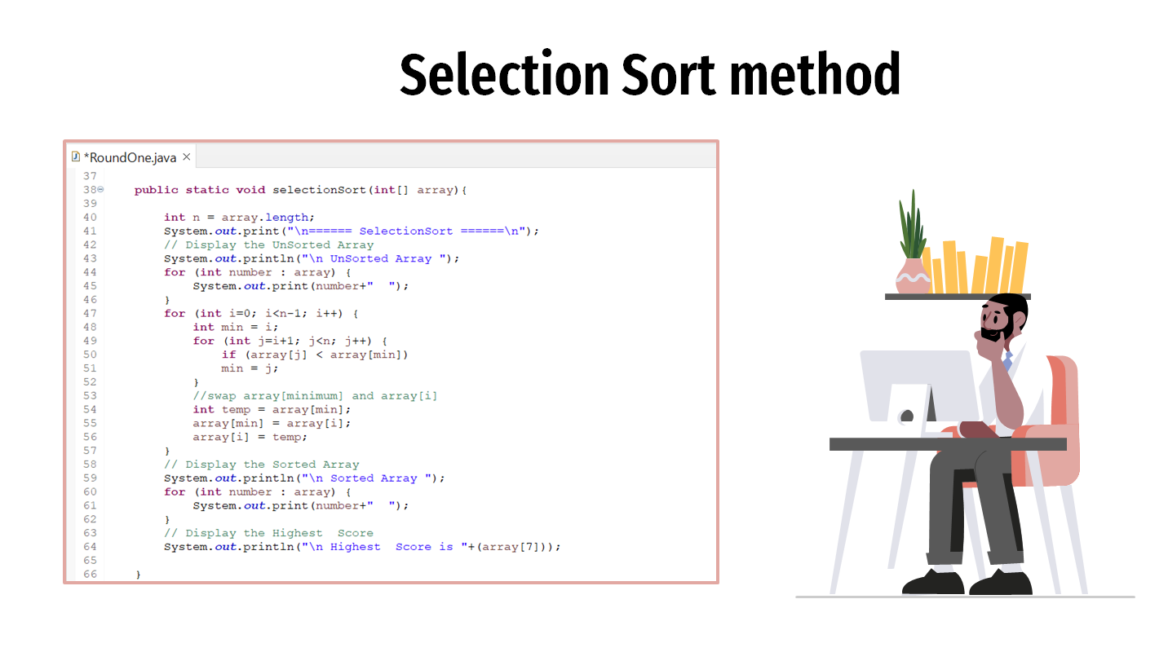

1. **Searching Algorithm**

Searching algorithms are employed to find a specific item or determine its absence in a collection of data. Notable examples include:

* **Linear Search**

Linear Search is a simple searching algorithm that checks each element in the list until a match is found or the whole list has been searched. It is not the most efficient for large datasets, but it is easy to understand and implement.

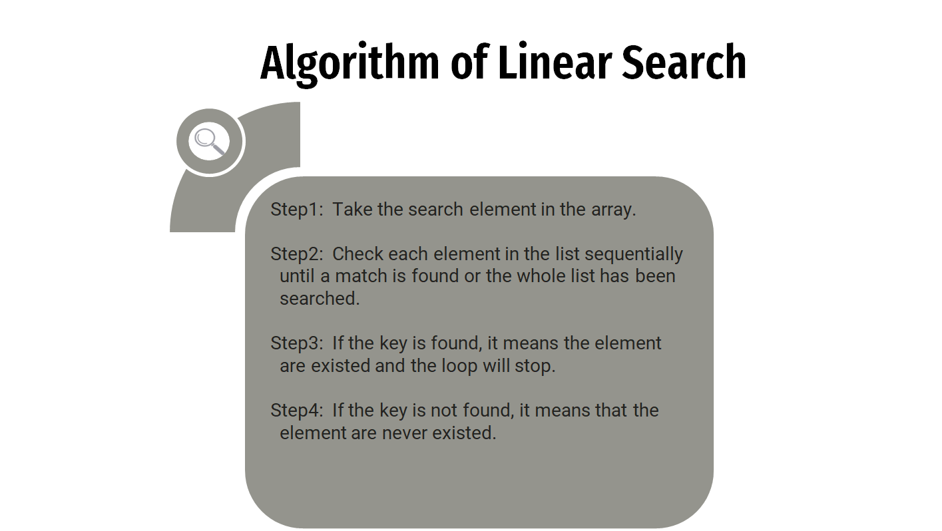

15

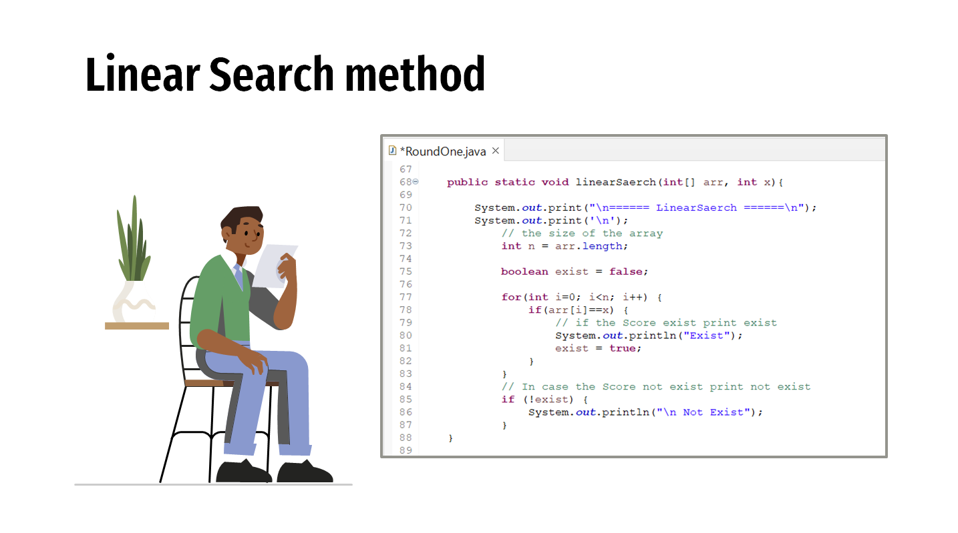

**Graph Algorithms**

Graph algorithms deal with data structures that consist of nodes and edges, representing relationships between different entities.

[Include examples of graph algorithms such as Depth-First Search (DFS) or Dijkstra's Algorithm with brief explanations and code snippets.]

Algorithms play a fundamental role in computer science and programming, providing systematic approaches to problem-solving. The examples provided for sorting, searching, and graph algorithms offer a glimpse into the diverse applications and methodologies within this vast field. As technology continues to evolve, so too will the algorithms that underpin our digital world.[5]

16

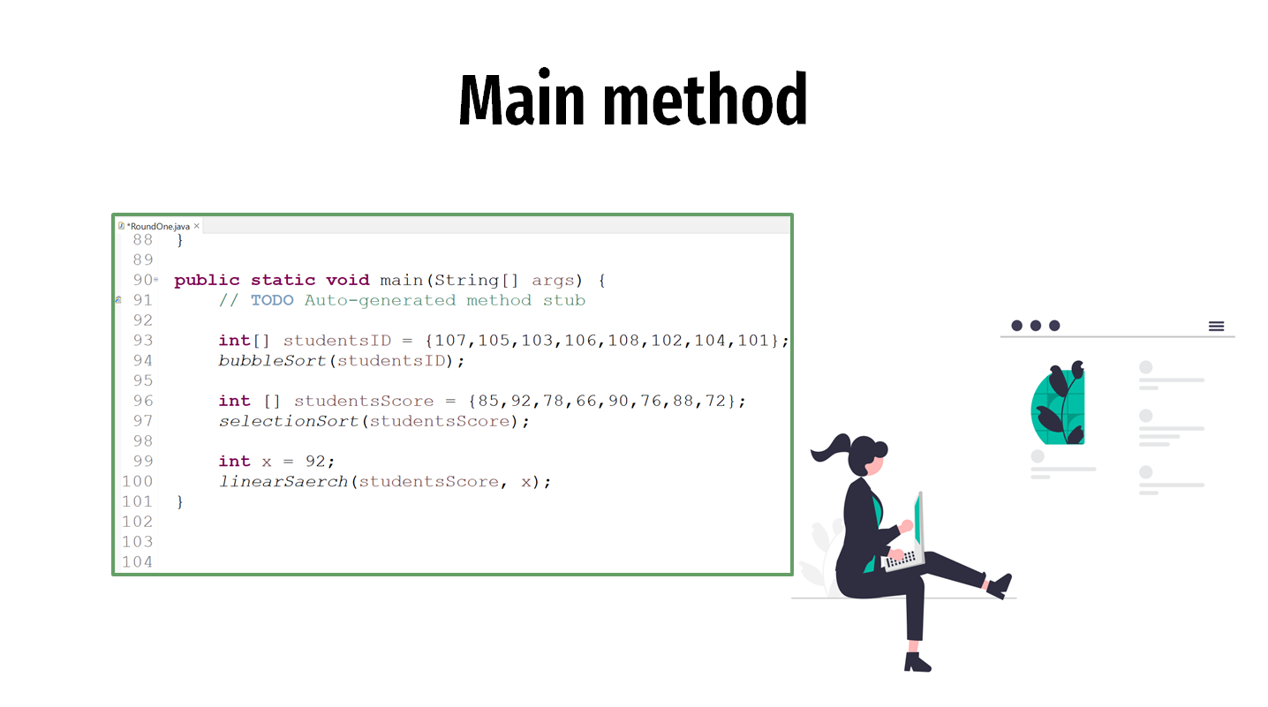

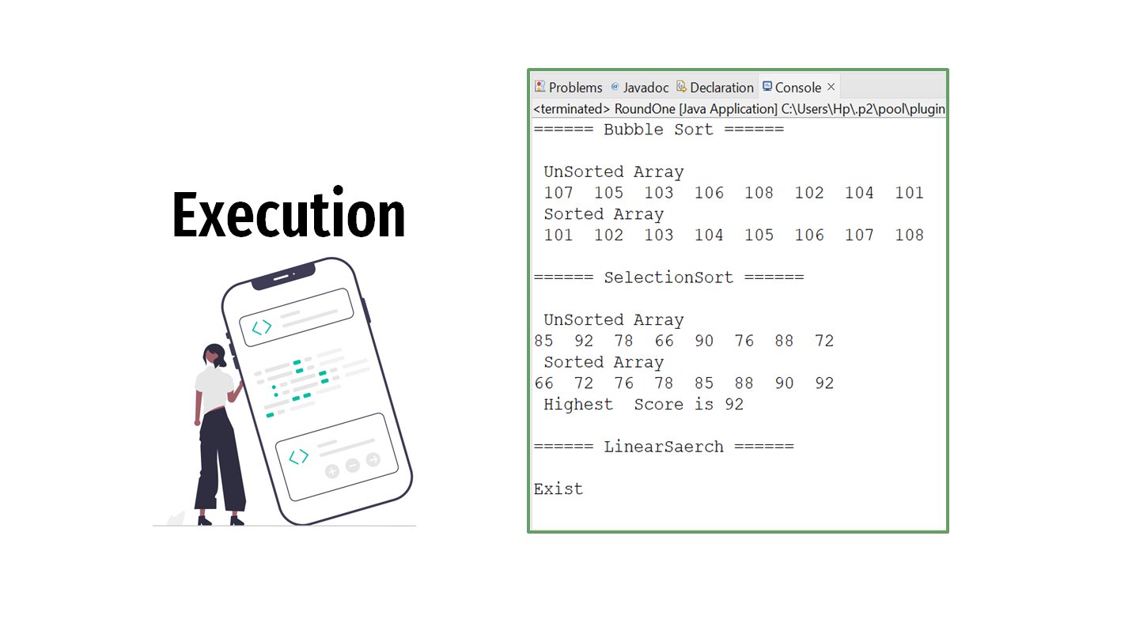

17

How computer understand programming

In the realm of software development, the essence lies in a series of instructions that computers must follow to execute specific tasks. These instructions, forming the code, act as a crucial link between human understanding and machine execution. To unravel the process by which computers comprehend code, it is essential to explore the distinctions between high-level programming languages, low-level programming languages, and the integral role played by translators.[6]

**High-level programming languages,** such as Python, Java, and C++, are crafted for human readability and ease of use. They provide constructs and syntax that closely resemble natural language, abstracting away the intricacies of machine architecture. Programmers leverage high-level languages to express algorithms and logic in a manner that is both intuitive and efficient, fostering productivity in software development.[6]

In contrast, **low-level programming languages** delve deeper into the machine architecture, offering more direct control over hardware resources. Examples of low-level languages include assembly language and machine code. While these languages may be less human-readable and more challenging to work with, they afford programmers the granularity of control needed for certain applications.[6]

**Translators** are indispensable in the process of converting human-readable code into machine-executable instructions. Several types of translators facilitate this conversion:

**Assembler:** This translator converts assembly language code into machine code by translating symbolic representations of instructions into binary code, comprehensible to the computer's central processing unit (CPU). An example is NASM (Net wide Assembler) designed for the x86 architecture.

**Compiler:** Unlike an assembler, a compiler transforms the entire source code written in a high-level programming language into either machine code or an intermediate code. It analyzes the entire program and generates an executable file that can run independently of the original source code. An example is GCC (GNU Compiler Collection) used for languages like C and C++.

18

**Interpreter:** An interpreter executes high-level source code line by line without generating a separate executable file. It reads, interprets, and executes each statement sequentially. A common example is the Python interpreter used for running Python scripts.

**Linker:** The linker resolves references between different modules or object files, producing a single executable file. It combines object code generated by the compiler and resolves external references, creating a complete executable program. An example is GNU ld (Linker) used for linking object files.

In the intricate dance between programmers and computers, translators serve as interpreters of human intent, converting abstract code into a language the machine comprehends. The choice between high-level and low-level languages depends on the balance between readability and control, while translators facilitate the seamless translation of code from the programmer's mind to the computer's understanding.[6]

Defining Programming Paradigms

Programming Paradigms refer to the fundamental styles and approaches used in writing code. They provide a conceptual framework for developers to solve problems and organize their programs effectively. At its core, understanding Programming Paradigms is crucial for any developer striving to create efficient and maintainable software.[7]

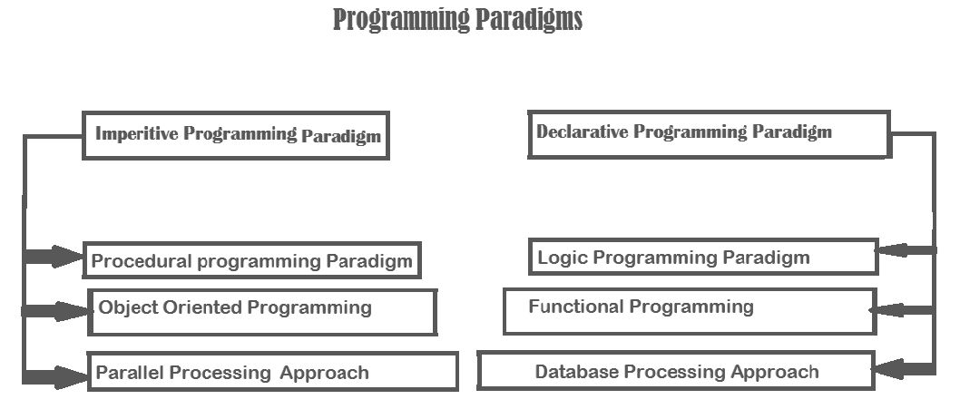

Fig.4. Programming Paradigms

19

Types of Programming Paradigms

In the dynamic realm of programming paradigms, Procedural Programming stands out as a straightforward and easy-to-understand approach, particularly well-suited for smaller projects or tasks where simplicity is essential. Let's delve into the intricacies of Procedural Programming, exploring its principles, advantages, and considerations in modern software development.[7]

1. **Procedural Programming Paradigm**

At its core, Procedural Programming is defined as a language derived from structured programming. It relies on the use of call procedures, which are essentially functions, routines, or subroutines that specify the computational steps that need to be performed. This approach organizes code into procedures or routines, facilitating a systematic and step-by-step execution of tasks.[7]

**Origins and Principles**

Procedural Programming finds its roots in structured programming, emphasizing a linear flow of control and logical structures. The principles are built around breaking down a program into smaller, manageable procedures, promoting simplicity and clarity in the codebase.

**How Procedural Programming Works**

*Code Organization through Procedures*

One of the fundamental aspects of Procedural Programming is the organization of code into procedures. These procedures encapsulate specific sets of instructions, promoting modularity and ease of maintenance. The sequential execution of procedures ensures a well-structured and comprehensible program flow.[7]

*Key Components and Syntax*

Procedural Programming employs key components such as variables, data structures, and control flow statements. The syntax is typically straightforward, making it accessible for developers with varying levels of expertise. The emphasis on procedures simplifies debugging and troubleshooting, enhancing the overall development process.

20

**Pros of Procedural Programming**

*Simplicity and Clear Structure*

The foremost advantage of Procedural Programming lies in its simplicity and clear structure. The linear execution of procedures makes the code easy to follow, reducing complexity and enhancing readability. This makes it an excellent choice for projects where straightforwardness is paramount.

*Suitability for Smaller Projects*

Procedural Programming is particularly well-suited for smaller projects. The uncomplicated nature of the paradigm allows developers to quickly grasp and contribute to the codebase, making it an efficient choice for projects with limited scope and scale.

**Cons of Procedural Programming**

*Limited Code Reuse*

Despite its simplicity, Procedural Programming has its drawbacks. One notable limitation is the challenge of code reuse. As procedures are often designed for specific tasks, achieving high levels of code reuse can be challenging, potentially leading to redundancy in larger projects.

*Complexity in Larger Projects*

While ideal for smaller projects, Procedural Programming may become complex and unwieldy in larger endeavors. Managing a vast number of procedures and maintaining a clear code structure can be challenging, necessitating careful consideration before opting for this paradigm.

**Real-world Applications**

*Examples of Successful Implementation*

Procedural Programming has found success in various real-world applications. From embedded systems to scripting languages, its simplicity makes it an excellent choice for scenarios where rapid development and execution are crucial.

21

**Choosing Procedural Programming Wisely**

*Project Size Considerations*

When deciding on a programming paradigm, project size is a critical consideration. Procedural Programming shines in smaller projects where a linear and straightforward approach is advantageous. For larger projects, however, careful evaluation is required to ensure scalability and maintainability.

*Identifying Appropriate Use Cases*

Understanding the nature of the project and its requirements is essential. Procedural Programming might be the perfect fit for tasks that demand simplicity and a clear step-by-step execution. Assessing the project's characteristics helps in making an informed decision.

**Alternatives to Procedural Programming**

*Object-Oriented Programming*

As an alternative to Procedural Programming, Object-Oriented Programming (OOP) introduces concepts like classes and objects, promoting code reuse and encapsulation. OOP is favored for its ability to model real-world entities, providing a different approach to software design.

*Functional Programming*

Another alternative is Functional Programming, which treats computation as the evaluation of mathematical functions. With a focus on immutability and avoiding side effects, Functional Programming offers a different paradigm that appeals to certain development scenarios.

**The Future of Procedural Programming**

*Evolving Trends*

In the ever-evolving landscape of software development, Procedural Programming continues to adapt to new trends. Its simplicity remains an asset, especially when combined with modern development practices.

22

*Adaptation in Modern Development*

Procedural Programming is not a relic of the past but an adaptable paradigm that can coexist with more modern approaches. Its principles find application in various development scenarios, demonstrating its enduring relevance.

**Case Studies**

*Success Stories*

Several success stories highlight the effectiveness of Procedural Programming. From game development to system programming, its application has led to the creation of robust and efficient solutions.

*Challenges Faced and Overcome*

While successful, Procedural Programming is not without challenges. Understanding the challenges faced in specific cases and the strategies employed to overcome them provides valuable insights for developers.

**Tips for Effective Procedural Programming**

*Best Practices*

Adhering to best practices is crucial for effective Procedural Programming. This includes modular design, meaningful variable names, and proper documentation. Following these practices enhances code maintainability and collaboration.

*Common Mistakes to Avoid*

Avoiding common mistakes is equally important. Overly complex procedures, inadequate error handling, and poor organization can hinder the effectiveness of Procedural Programming. Awareness of potential pitfalls contributes to better code quality.

Procedural Programming offers a simple and clear structure, making it an excellent choice for smaller projects. Its suitability, however, diminishes in the face of larger and more complex endeavors. Understanding its pros and cons, coupled with a thoughtful evaluation of project requirements, is key to leveraging Procedural Programming effectively.

23

1. **Object-Oriented Programming (OOP)**

Object-oriented programming (OOP) stands as a paradigm that revolutionizes the way we organize and structure code. By focusing on the creation of objects that mirror real-world entities, OOP introduces a level of modularity and reusability that enhances the efficiency and maintainability of code.

In the realm of programming, Object-Oriented Programming (OOP) takes center stage by offering a unique approach to code organization. Unlike traditional procedural programming, OOP revolves around the concept of objects, which encapsulate both data and behavior.[7]

**Focus: Organizing Code around Objects**

At the core of OOP lies the focus on organizing code around objects. This methodology proves instrumental in achieving clarity and structure in the development process.

**Classes & Objects**

The cornerstone of OOP is the creation of classes and objects. These entities serve as the bedrock, encapsulating both data and behavior within their realms.

**Encapsulation**

Encapsulation, a fundamental principle, involves bundling data and methods that operate on the data. This technique aids in hiding internal details and restricting access to specific parts of the object.

**Inheritance**

Another pivotal concept in OOP is inheritance. This mechanism allows a class (subclass or derived class) to inherit properties and behaviors from another class (superclass or base class).

24

**Example of Inheritance in Java**

Java code

// Base class (superclass)

class Animal {

void eat() {

System.out.println("This animal eats food.");

}

}

// Derived class (subclass) inheriting from Animal

class Dog extends Animal {

void bark() {

System.out.println("The dog barks.");

}

}

**Polymorphism**

Polymorphism, a key tenet in OOP, allows objects of different types to be treated as objects of a common type. This occurs in two forms: compile-time (method overloading) and runtime (method overriding).

**Pros and Cons of Object-Oriented Programming**

As with any programming paradigm, OOP has its set of advantages and disadvantages.

25

**Pros:**

* Reusable code
* Modular structure
* Supports abstraction

**Cons:**

* Can be complex
* Potential for performance overhead

**Object**

The term "object" in OOP signifies a real-world entity, be it physical or logical. Examples range from a pen or chair to intangible entities like the banking system.

**Object Characteristics**

Taking a pen as an example, its name (Reynolds), color (white), and the act of writing collectively define its state and behavior.

**Class**

A class serves as a template or blueprint from which objects are created. It encapsulates common properties shared by a group of objects.

**Properties of Java Classes**

* Class is not a real-world entity; it's a template.
* Class does not occupy memory.
* It comprises variables of different data types and methods.

26

**Syntax to Declare a Class in Java**

Java code

class <class_name> {

field;

method;

}

**Components of Java Classes**

Class declarations can include modifiers, the class keyword, class name, superclass (if any), interfaces (if any), and the class body.

**Constructors: Architects of New Objects**

Constructors play a crucial role in initializing new objects, defining their state and behavior.

**Key Points about Constructors**

* Name same as class
* Used for initialization
* Default and parameterized constructors

27

**Constructors Example in Java**

Java code

class Student {

int id;

String name;

// Parameterized Constructor

public Student(int studentId, String studentName) {

id = studentId;

name = studentName;

}

}

public class TestStudent {

public static void main(String[] args) {

// Creating an object and invoking the constructor

Student student1 = new Student(101, "John");

// Accessing the initialized values

System.out.println("Student ID: " + student1.id);

System.out.println("Student Name: " + student1.name);

}

}

28

**Instance Variable in Java**

Instance variables, created inside the class but outside methods, get memory at runtime when an object is created.

**Object Class Example in Java**

Java code

// Another class creating Student class

class Student {

int id;

String name;

}

// Creating another class TestStudent1 with the main method

class TestStudent1 {

public static void main(String args[]) {

Student s1 = new Student();

System.out.println(s1.id);

System.out.println(s1.name);

}

}

Object-Oriented Programming (OOP) emerges as a powerful paradigm, weaving a tapestry of organization, efficiency, and code reusability. By understanding its core principles, developers can craft solutions that stand the test of time.

29

1. **Event-Driven Programming Paradigm**

Event-Driven Programming has become a cornerstone in modern software development, providing a dynamic approach to handling events and user interactions. In this article, we will delve into the intricacies of Event Driven Paradigm, exploring its purpose, key components, and its application in Java GUI development.[7]

**Event Driven Programs**

Event Driven Programming is a programming paradigm that revolves around the structure and flow of code in response to specific events or changes in an application or system. Typically used with GUI operating systems, it enables software to respond promptly to events from external sources, such as user input or system changes.[7]

**Purpose of Event Driven Programming**

The primary goal of Event Driven Programming is to make software more responsive to user actions and to simplify the development process. By providing a clear separation between event handling and other aspects of software design, it enhances the efficiency and maintainability of applications.

**Key Components of Event Driven Paradigm**

Event Driven Paradigm comprises three key components: Event Handling, Event Loop, and Event Queue. Event Handling involves responding to events triggered by user actions. The Event Loop is a continuous process that checks for queued events, ensuring the application's responsiveness. The Event Queue holds events waiting to be processed in the order received.[7]

30

**Event Handling in JavaScript**

Let's explore Event Handling in a popular programming language – JavaScript. Consider a simple example of a button click event in JavaScript code. This exemplifies the essence of Event Driven Programming, where the code responds to a specific user action.

Java Script code

// JavaScript code for button click event

document.getElementById("myButton").addEventListener("click", function(){

alert("Button clicked!");

});

**Imperative VS Event-Driven Paradigms**

Understanding the differences between Imperative and Event-Driven Paradigms is crucial. While Imperative Programming focuses on explicit commands, Event-Driven Programming responds to events, making it ideal for interactive applications.

**Java GUI Application**

Java GUI Applications are known for their rich and interactive user interfaces. Event Driven Programming plays a pivotal role in Java GUIs, ensuring seamless user experiences and responsiveness.

**Java Swing GUI Components**

Java Swing GUI Components form the building blocks of Java GUIs. These components seamlessly integrate with Event Driven Programming, enhancing the interactivity and usability of Java applications.

31

**The Java Event Model**

The Java Event Model consists of an event generator, listener, and interface. An event generator informs a listener of an event by sending a message. Interfaces standardize event-handling methods, and classes implementing listeners must adhere to these interfaces.

**Events in Java**

In Java, events are subclasses of AWTEvent, and event sources in Swing are subclasses of J Component. Programs must actively listen for events to respond appropriately to user interactions.

**Java Class AWTEvent and Its Subclasses**

Java Class AWTEvent is a key element in the Java Event Model. Understanding its subclasses is essential for effective event handling in Java applications.

**Components and their Event Handlers**

Different GUI components handle events differently. Understanding how components and their event handlers interact is crucial for developing robust and responsive applications.

**The Java Event Model in Action**

Consider the Item Event class associated with clicking a checkbox, radio button, or list item. To handle such events, listeners are created using addItemListener, showcasing the practical application of the Java Event Model.

Event Driven Programming is a powerful paradigm that enhances software responsiveness and simplifies development. Understanding its key components, application in Java GUIs, and the Java Event Model empowers developers to create interactive and user-friendly applications.

32

Relationship between Programming Paradigms

Understanding the Relationship between Programming Paradigms is crucial in modern software development. Developers often combine different paradigms to leverage their strengths and address the limitations of each.[7]

**Relationship between Procedural and Object-Oriented Programming**

Procedural and Object-Oriented Programming are not mutually exclusive; in fact, they can complement each other. For instance, a program may use procedural code for low-level operations and leverage the power of objects for high-level structuring. This blend allows for efficient resource management and code organization.[8]

**Relationship between Event-Driven and Object-Oriented Programming**

The dynamic nature of Event-Driven Programming finds synergy with the structured approach of Object-Oriented Programming. In applications where user interactions trigger events, combining these paradigms enhances the user experience and makes the code more modular and maintainable.[8]

Programming Paradigms are the cornerstone of software development, providing developers with diverse tools to tackle various challenges. Understanding the types of paradigms and their relationships empowers developers to make informed decisions, leading to the creation of robust and scalable software.

33

Software Development Life Cycle (SDLC)

In the realm of software development, the Software Development Life Cycle (SDLC) plays a pivotal role. This systematic process is crucial for software organizations, guiding them through the intricate journey of software creation, maintenance, replacement, and enhancement.[9]

**What is it SDLC?**

SDLC, or Software Development Life Cycle, is essentially a roadmap that outlines the entire process of software development within an organization. It provides a structured plan for designing, developing, testing, and maintaining specific software products.[9]

**Deciphering the Stages of SDLC**

In the intricate landscape of Software Development Life Cycle (SDLC), each stage plays a crucial role in shaping a successful software product. Let's delve deeper into the core stages of SDLC, unraveling the intricacies of planning, design, implementation, testing, and deployment.[10]

**1. Planning Phase:**

The planning phase is the inception point of SDLC, where the foundation for the entire development process is laid. Here, meticulous planning involves defining the project scope, setting goals, and establishing timelines. The process includes rigorous requirement analysis, resource planning, and risk assessment. The aim is to create a comprehensive roadmap that guides the development team throughout the project lifecycle, ensuring alignment with business objectives and mitigating potential risks.[10]

34

**2. Designing Phase:**

Moving to the designing phase, the focus shifts to creating a blueprint for the software based on the requirements outlined in the planning stage. This involves detailed architectural design, database design, and user interface design. The significance of this phase lies in crafting a robust and scalable structure for the software, ensuring that it aligns seamlessly with the intended functionalities outlined during the planning phase.[10]

**3. Implementation Phase:**

The implementation phase, often regarded as the heart of SDLC, involves the actual coding and programming activities. Developers bring the design to life by translating it into executable code. This phase demands precision and adherence to the design specifications crafted in the previous stage. Challenges may arise, such as coding errors or evolving requirements, and this is where agile methodologies come into play, offering adaptability and responsiveness to changes.[10]

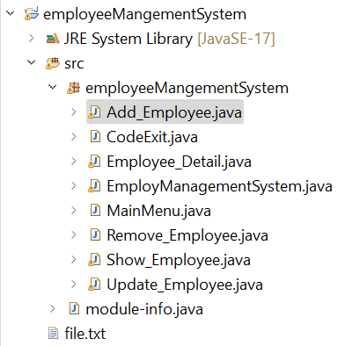

This is my employee Management System classes in java; I’ll explain each of them.

35

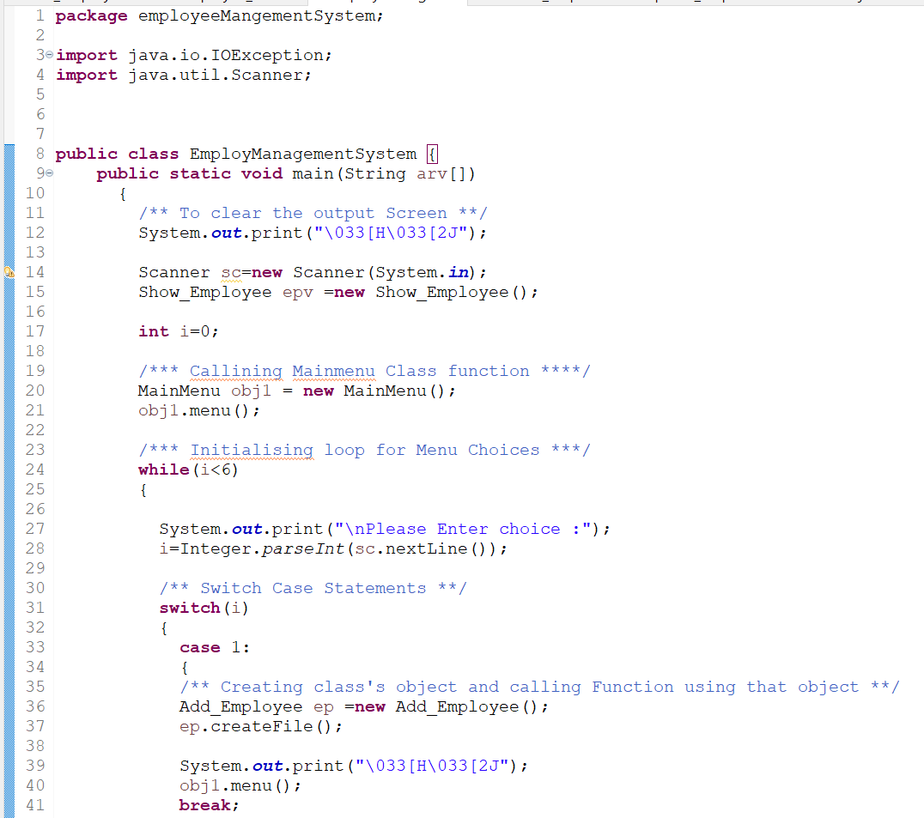

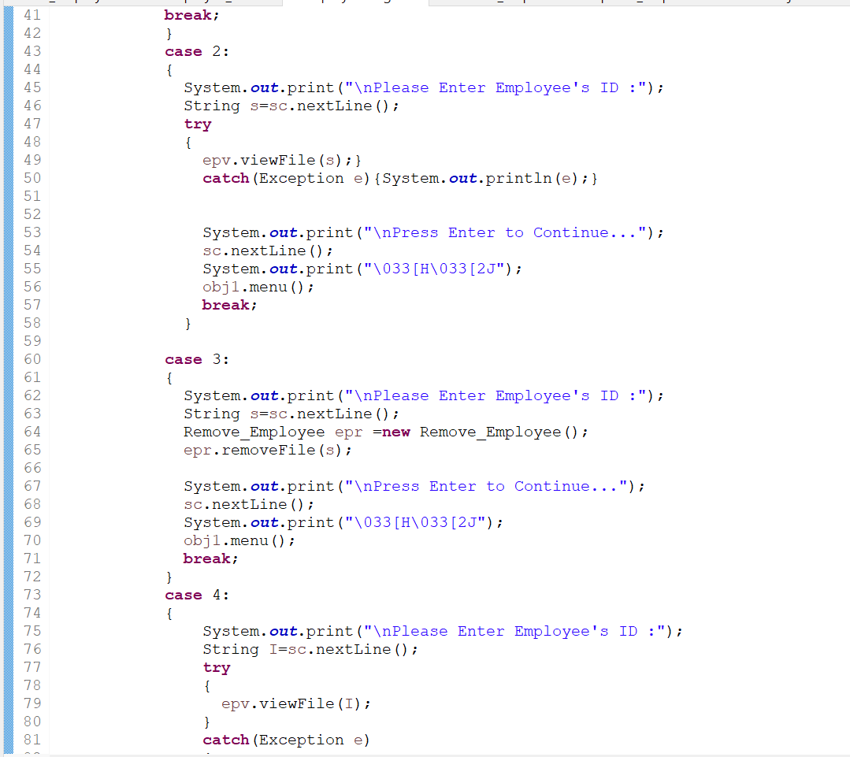

36

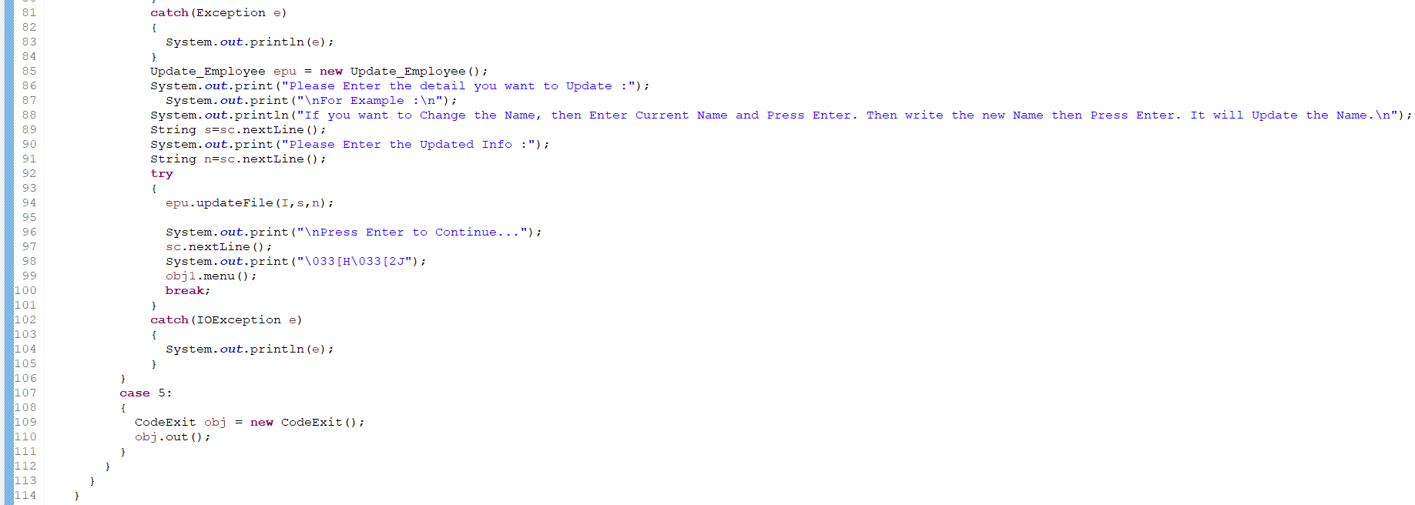

Employee management is a critical aspect of running a successful business. In today's fast-paced and dynamic work environment, organizations require efficient systems to handle various aspects of employee management. One such crucial component is the EmployManagementSystem class, a key player in ensuring smooth operations within an employee management system.

Employee Management Systems (EMS) has become indispensable tools for organizations of all sizes. These systems streamline various HR processes, ensuring optimal utilization of resources and enhancing overall productivity. At the heart of these systems lies the EmployManagementSystem class, a sophisticated module designed to handle a myriad of tasks related to employee management.

The EmployManagementSystem class serves as the backbone of an employee management system. It is a specialized component responsible for overseeing and orchestrating key functions within the system. By leveraging the capabilities of this class, organizations can achieve a seamless and organized approach to managing their workforce. The EmployManagementSystem class is a software entity designed to encapsulate the essential functionalities required for effective employee management. Its primary purpose is to serve as an interface between the user and the underlying system, facilitating the execution of various tasks related to HR management. This class encompasses a range of features, including employee data storage, performance tracking, payroll management, and communication facilitation. Its modular design allows for easy integration with other components, creating a comprehensive solution for organizational HR needs.

37

In the broader context of an employee management system, the EmployManagementSystem class collaborates with other modules such as payroll systems, attendance tracking, and performance evaluation tools. This synergy ensures a holistic approach to employee management, where data seamlessly flows between different components.

**Key Responsibilities**

Employee Data Storage and Retrieval

One of the primary tasks of the EmployManagementSystem class is to efficiently store and retrieve employee data. This includes personal information, job details, performance history, and other relevant data points. The class ensures data accuracy and accessibility, enabling HR professionals to make informed decisions.

Performance Tracking and Evaluation

Performance management is a crucial aspect of employee development. The EmployManagementSystem class plays a pivotal role in tracking employee performance metrics, facilitating timely evaluations, and providing actionable insights for improvement.

Payroll and Benefits Management

Efficient payroll and benefits management are essential for employee satisfaction. The EmployManagementSystem class automates payroll processes, calculates benefits, and ensures compliance with financial regulations, reducing the burden on HR teams.

Role in Employee Communication and Feedback

Facilitating communication between employees and management is vital for a healthy work environment. The EmployManagementSystem class includes features that enable seamless communication, feedback collection, and performance reviews, fostering a collaborative workplace culture.

38

**Advantages of Using EmployManagementSystem Class**

Enhanced Efficiency and Accuracy

The EmployManagementSystem class significantly enhances the efficiency and accuracy of HR processes. By automating routine tasks, it minimizes errors and allows HR professionals to focus on strategic aspects of employee management.

Streamlined Workflow

Organizations benefit from a streamlined workflow as the EmployManagementSystem class optimizes HR processes. This results in faster decision-making, reduced administrative overhead, and improved overall productivity.

Improved Decision-Making

Access to real-time data and analytics empowers organizations to make informed decisions. The EmployManagementSystem class provides valuable insights into employee performance, helping management make strategic choices for the company's success.

Scalability and Adaptability

As organizations grow, their HR needs evolve. The modular design of the EmployManagementSystem class ensures scalability and adaptability, allowing organizations to seamlessly integrate new features and functionalities as their workforce expands.

39

**Common Challenges in Implementing EmployManagementSystem Class**

While the EmployManagementSystem class offers numerous benefits, organizations may face challenges during implementation. Common issues include data migration complexities, user resistance, and integration challenges with existing systems.

**Strategies to Overcome Potential Issues**

Addressing these challenges requires a strategic approach. Organizations can mitigate issues by conducting thorough training programs, involving employees in the implementation process, and seeking expert assistance for seamless integration.

**Success Stories of Companies Using EmployManagementSystem Class**

Several organizations have witnessed remarkable improvements in their employee management processes after implementing the EmployManagementSystem class. Case studies highlight success stories, showcasing the positive impact on employee satisfaction, productivity, and overall organizational success.

**Real-World Examples of Improved Employee Management**

Examining real-world examples provides insights into the practical benefits of the EmployManagementSystem class. Companies from diverse industries have experienced enhanced efficiency, reduced costs, and improved employee engagement through the effective utilization of this class.

**Emerging Technologies in Employee Management Systems**

The landscape of employee management systems is continually evolving. Future trends include the integration of artificial intelligence, machine learning, and advanced analytics to further enhance the capabilities of the EmployManagementSystem class.

40

**Potential Enhancements to EmployManagementSystem Class**

Continuous innovation is key to staying ahead. Potential enhancements may include predictive analytics for workforce planning, improved user interfaces for better user experience, and integration with emerging technologies to address evolving HR challenges.

**Comparison with Other Employee Management Components**

How EmployManagementSystem Class Differs from Other Modules

While various modules contribute to employee management, the EmployManagementSystem class stands out due to its comprehensive approach. It integrates multiple functions seamlessly, distinguishing itself from standalone modules that may focus on specific aspects of HR.

Complementary Roles within the System

Understanding the synergy between the EmployManagementSystem class and other modules is essential. Recognizing their complementary roles ensures a cohesive and efficient employee management system.

**Security Measures**

Safeguarding Sensitive Employee Information

The security of employee data is paramount. The EmployManagementSystem class incorporates robust security measures such as data encryption, access controls, and regular audits to safeguard sensitive information from unauthorized access.

Data Encryption and Access Controls

Implementing encryption protocols and access controls ensures that only authorized personnel have access to specific employee data. This dual-layered security approach enhances the overall integrity of the system.

41

**Industry Standards and Compliance**

Adherence to Legal Regulations

Compliance with legal regulations is a non-negotiable aspect of employee management. The EmployManagementSystem class ensures adherence to labor laws, data protection regulations, and other industry-specific compliance requirements.

Ensuring Compliance with Industry Standards

In addition to legal compliance, adhering to industry standards is essential. The EmployManagementSystem class is designed to meet or exceed established standards, ensuring reliability, security, and interoperability.

**The Future Landscape of Employee Management**

Predictions for the Evolution of Employee Management Systems

Looking ahead, employee management systems are poised for significant advancements. Predictions include the integration of advanced analytics for predictive modeling, further automation of routine tasks, and enhanced employee engagement features within the EmployManagementSystem class.

Potential Innovations in EmployManagementSystem Class

Innovation is the driving force behind progress. Anticipated innovations in the EmployManagementSystem class may include the integration of virtual reality for training purposes, AI-driven predictive analytics, and enhanced communication features for remote and hybrid work environments.

The EmployManagementSystem class plays a pivotal role in modern employee management systems. Its multifaceted functionalities contribute to enhanced efficiency, streamlined workflows, and improved decision-making within organizations. As the landscape of employee management continues to evolve, the EmployManagementSystem class remains a cornerstone for success.

42

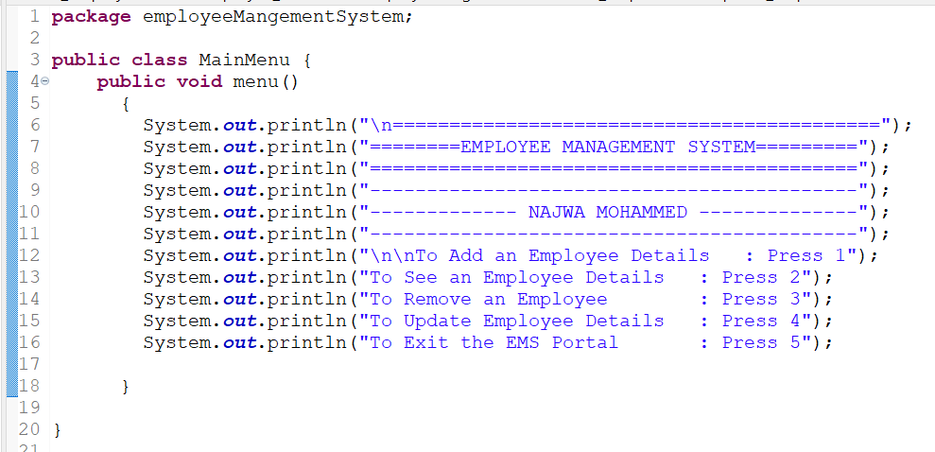

Employee management systems rely on a well-designed MainMenu class to provide users with a structured interface for efficient navigation and interaction. This essential component ensures a user-friendly experience, contributing to the overall success of the system.

The MainMenu class serves as the gateway to various features within an employee management system. From accessing employee records to initiating administrative tasks, its functionalities are diverse and integral to the system's operation.

An effective MainMenu class facilitates smooth navigation, allowing users to access different modules and features effortlessly. User interaction is streamlined, enhancing the overall user experience and promoting efficiency in daily operations.

43

Collaboration with other classes is crucial for a cohesive employee management system. The MainMenu class often acts as a central hub, seamlessly integrating with other components to ensure a synchronized and interconnected system.

A user-friendly interface is paramount for the success of any MainMenu class. Design principles focus on simplicity, clarity, and intuitiveness, ensuring that users can navigate the system with minimal training.

Adding or Removing Features Based on Requirements

Customization options should extend to the addition or removal of features within the MainMenu class. This adaptability allows organizations to tailor the system to their evolving needs.

Providing a Flexible and Scalable Solution

Scalability is a crucial aspect of the MainMenu class. A flexible architecture ensures that the system can grow with the organization, accommodating increased data and user demands.

The MainMenu class is a linchpin in the realm of employee management systems. Its role in facilitating efficient navigation, ensuring robust security measures, and contributing to overall system flexibility cannot be overstated. Organizations that prioritize the development and optimization of the MainMenu class stand to gain a competitive advantage in the dynamic landscape of employee management.

44

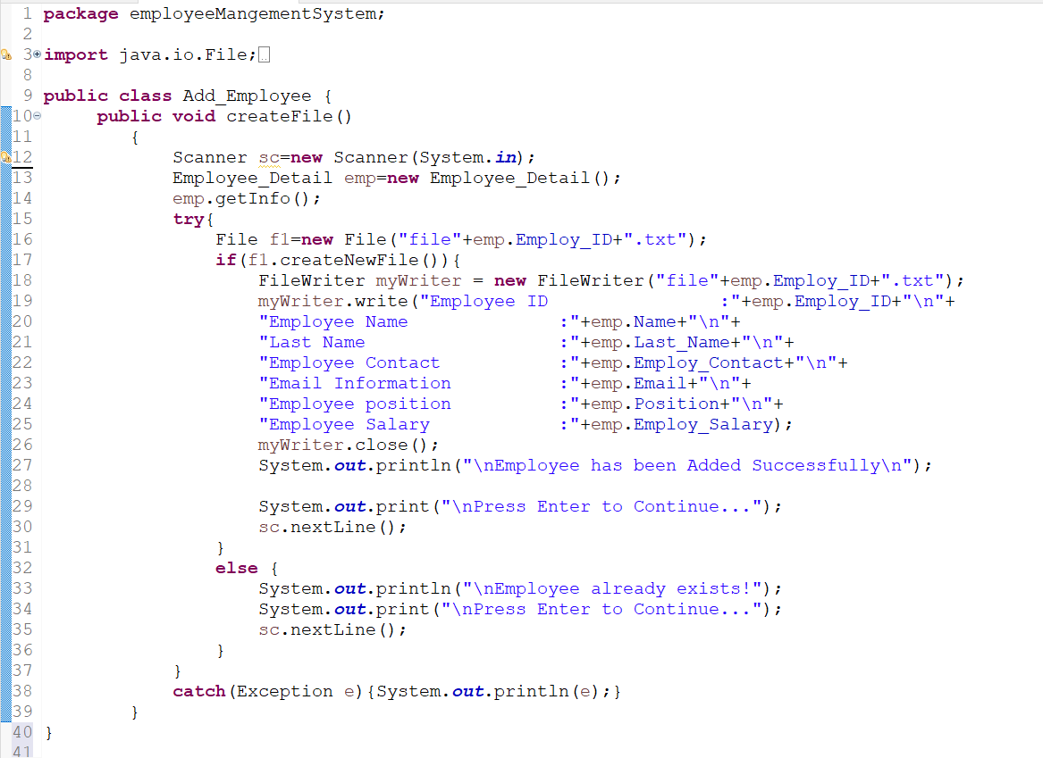

The serves as the cornerstone for managing employee data within a system. It encapsulates essential attributes and methods that facilitate the seamless addition of new employees to the database. Its primary goal is to simplify and streamline the data entry process, ensuring accuracy and consistency.

Efficiency is the key to any successful employee management system, and the Add_Employee Class plays a crucial role in achieving just that. By offering a structured approach to employee data input, it minimizes errors and enhances overall system efficiency. Let's explore its functionalities and features in more detail.

At its core, the Add_Employee Class excels in handling employee details input. It incorporates robust validations and error-handling mechanisms, preventing erroneous data entry. The class also seamlessly interacts with the database, ensuring that the entered information is stored securely and accurately.

Simplicity is the hallmark of the Add_Employee Class. By simplifying the data Add_Employee Class entry process, it reduces the time spent on manual input and minimizes the likelihood of errors. This not only accelerates the information retrieval process but also contributes to a positive user experience.

45

Despite its effectiveness, implementing the Add_Employee Class may pose challenges. Addressing these challenges head-on and providing viable solutions ensures a smooth integration process. Regular updates and improvements based on user feedback further enhance the class's performance.

The Add_Employee Class emerges as a linchpin in modern employee management systems. Its role in simplifying data entry, ensuring accuracy, and enhancing user experience cannot be overstated. Organizations embracing this class position themselves for increased efficiency and productivity.

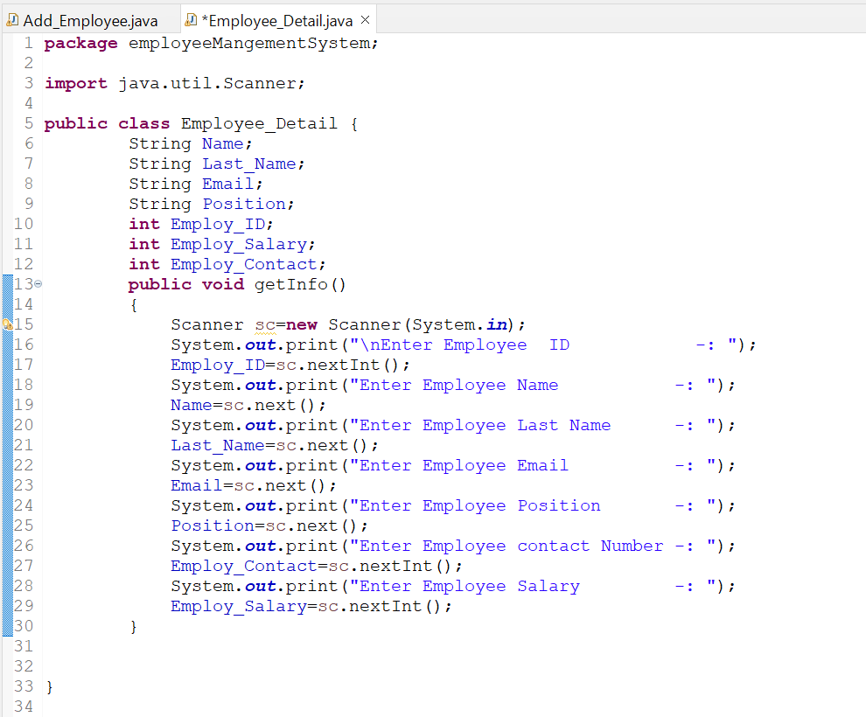

In the fast-paced world of employee management systems, the role of the Employee_Detail class cannot be overstated. This crucial element plays a pivotal role in organizing and streamlining employee information, ensuring efficient data management and enhancing overall system functionality.

46

At its core, the Employee_Detail class is a comprehensive structure designed to encapsulate all relevant information about an employee within an organization. This class acts as a repository for various attributes, each contributing to the creation of a detailed profile for every employee.

The Employee_Detail class encompasses a variety of attributes, including but not limited to employee ID, name, position, department, contact details, and more. Each attribute serves a specific purpose, collectively forming a robust foundation for managing employee data.

This class goes beyond static information storage. It incorporates methods and functions that facilitate dynamic interactions with the data. For instance, it allows for the retrieval of specific information, updating records, and performing calculations related to employee metrics.

The advantages of incorporating the Employee_Detail class into an employee management system are manifold. It significantly improves the efficiency of managing employee information, leading to a reduction in redundancy and errors.

Employee management systems often face challenges related to perplexity - the complexity and uncertainty associated with vast amounts of data. The Employee_Detail class addresses these challenges by providing a structured and organized framework for data management.

In the dynamic environment of employee management, bursts of data are not uncommon. The Employee_Detail class is designed to handle such bursts effectively, ensuring that the system maintains optimal performance even during peak data influx.

Maintaining specificity in employee data is crucial for system functionality. The Employee_Detail class strikes a balance, offering detailed information while preserving the broader context of the employee management system.

While the technical aspects are essential, incorporating a human touch into the system design is equally vital. A conversational style in documentation and user interfaces enhances the overall user experience, making the system more accessible and user-friendly.

47

The Employee_Detail class is the backbone of effective employee management systems. Its role in organizing, storing, and retrieving employee information is indispensable. By addressing challenges, handling bursts of data, and maintaining a conversational style in documentation, this class ensures a seamless and user-friendly experience.

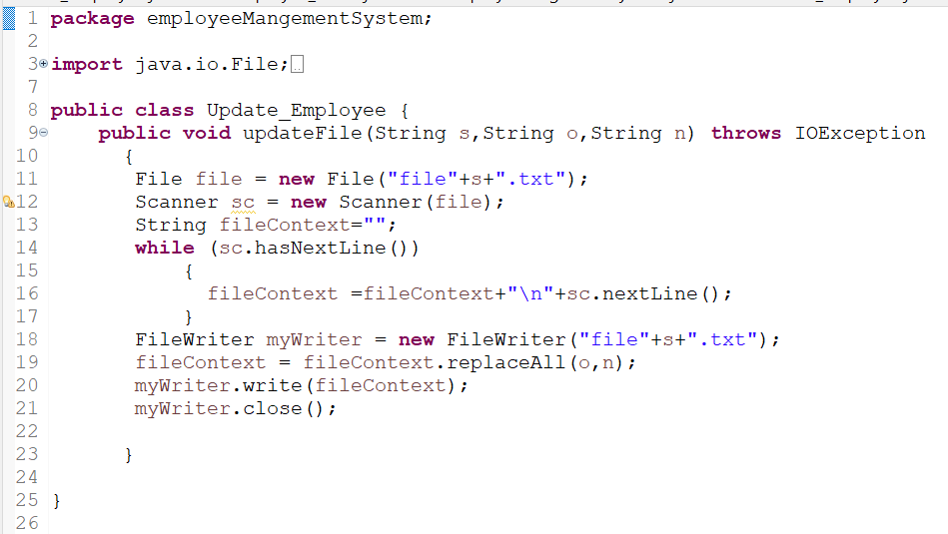

Employee management systems are the backbone of modern organizations, streamlining operations and ensuring efficient workforce management. One crucial aspect of these systems is the Update_Employee class, a powerful tool designed to enhance the management of employee data.

In the realm of employee management systems, staying up-to-date is paramount. Organizations need tools that not only manage employee data effectively but also adapt to the evolving needs of the business. This is where the Update_Employee class plays a pivotal role.

48

In the world of programming, classes are the building blocks of efficient code. They encapsulate data and functions, providing a structured way to manage information. The Update_Employee class, in particular, focuses on the dynamic task of updating employee data seamlessly.

The Update_Employee class boasts several features that make it an indispensable component of any employee management system. From modifying personal details to handling departmental changes, this class is designed to cater to a range of data update scenarios.

Implementing the Update_Employee class involves integrating it into the broader employee management system. This section will provide insights into the coding aspects, offering snippets to illustrate how developers can utilize this class effectively.

The advantages of incorporating the Update_Employee class are multifaceted. Improved data accuracy, streamlined processes, and resource efficiency are just a few of the benefits organizations can reap by leveraging this powerful tool.

With the increasing threat of data breaches, securing employee information is non-negotiable. This part of the article will discuss the security measures embedded in the Update_Employee class and offer recommendations for maintaining data integrity.

Usability is a key factor in the success of any software. The Update_Employee class contributes to a positive user experience, making employee management systems more accessible and user-friendly.

The Update_Employee class is not just a piece of code but a crucial component in the ever-evolving landscape of employee management systems. Its role in maintaining accurate and up-to-date employee data is indispensable for organizational success.

49

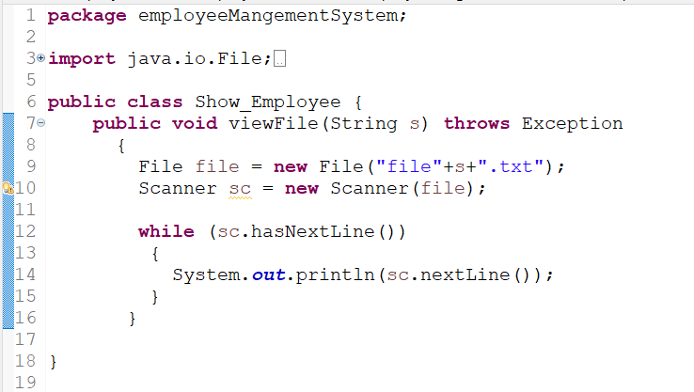

In the context of programming, classes are blueprints for creating objects, and in the case of employee management systems, they define how data is structured and manipulated. The Show_Employee class, in particular, is designed to handle the display of employee information, offering a user-friendly interface for accessing and presenting vital data.

The Show_Employee class boasts several features that contribute to its effectiveness. From customizable display options to seamless integration with other classes, it ensures that the representation of employee information is both comprehensive and user-friendly. This enables businesses to have a clear overview of their workforce.

Implementing the Show_Employee class involves integrating it into the broader employee management system. Programmers use coding languages like Python or Java to define the class and incorporate it into the system.

Efficient data representation is crucial in any employee management system. The Show_Employee class specializes in creating an organized and visually appealing display of employee information. This not only aids in decision-making processes but also enhances the overall user experience.

50

Comparing the Show_Employee class with other classes in employee management systems reveals its unique advantages. Unlike classes focused on data storage or computation, Show_Employee prioritizes information presentation. This makes it an invaluable asset for businesses aiming to improve the accessibility of employee data.

Numerous industries benefit from the implementation of the Show_Employee class. Whether in healthcare, finance, or manufacturing, businesses find value in presenting employee information efficiently. For instance, in healthcare, quick access to medical staff details can be critical in emergency situations.

While implementing the Show_Employee class, businesses may encounter challenges such as compatibility issues or customization complexities. However, these challenges can be addressed through thorough testing, documentation, and collaboration with experienced programmers.

As technology evolves so do employee management systems. The Show_Employee class is no exception. Future developments may include enhanced visualization features, integration with emerging technologies, and adaptability to evolving business needs.

The Show_Employee class plays a pivotal role in the success of employee management systems. Its ability to present information in a user-friendly manner contributes significantly to informed decision-making and overall organizational efficiency. As businesses continue to embrace digital transformation, the Show_Employee class stands as a testament to the importance of effective data representation.

51

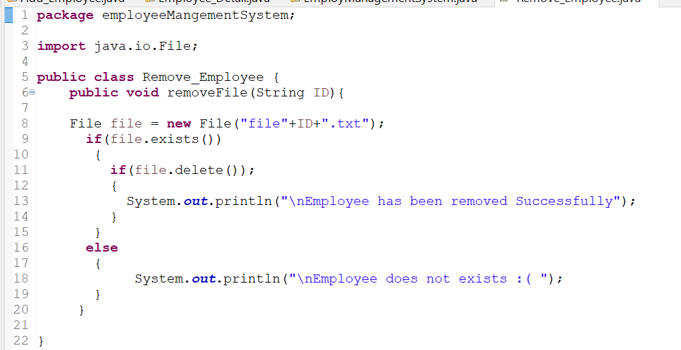

In the dynamic landscape of employee management systems, efficiency is paramount. The Remove_Employee class plays a crucial role in ensuring seamless operations within such systems. As organizations strive to maintain accurate and secure employee data, understanding the functions and benefits of this class becomes imperative.

The Remove_Employee class, in particular, is designed to handle the delicate task of employee data removal.

The primary function of the Remove_Employee class is to facilitate the smooth removal of employee records from the system. This involves not only deleting the data but ensuring that the process is accurate and secure. In essence, the class acts as the guardian of data integrity, making sure that only authorized personnel can initiate employee removal.

Integrating the Remove_Employee class into an existing employee management system is a strategic process. It involves coding the class to align with the system's architecture and ensuring compatibility with other classes. This adaptability makes it a versatile tool for different types of employee management systems.

52

The utilization of the Remove_Employee class brings about several benefits. Streamlining management processes and improving system efficiency are at the forefront. By automating the removal process, organizations can save time and resources, allowing for a more focused approach to other essential tasks.

While the Remove_Employee class enhances efficiency, challenges may arise during its implementation. Addressing these challenges promptly is crucial.

A comparative analysis distinguishes the Remove_Employee class from other classes in employee management systems. By assessing strengths and weaknesses, readers gain a comprehensive understanding of why Remove_Employee stands out.

The Remove_Employee class emerges as a cornerstone in the architecture of efficient employee management systems. Its role in data removal, coupled with its benefits and adaptability, makes it a valuable asset for organizations aiming to streamline their operations.

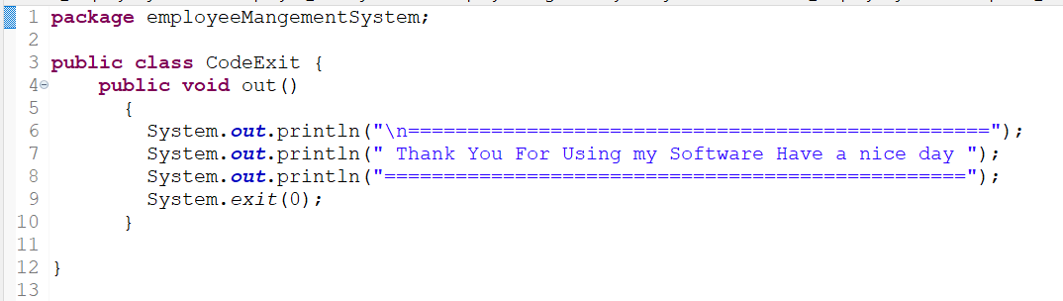

The CodeExit Class, in essence, serves as a crucial component in employee management systems. It is a specialized class designed to handle the exit processes of employees within an organization. This encompasses a range of tasks, from data organization to security measures

53

Data Organization and Storage: CodeExit excels in efficiently organizing and storing data related to employee exits. This includes details such as exit interviews, clearance processes, and documentation.

Integration with Other Classes: A standout feature is its seamless integration with other classes within the employee management system. This ensures a holistic approach to managing the employee lifecycle.

Security Measures Implemented: Recognizing the sensitivity of exit-related information, CodeExit incorporates robust security measures. Access controls and encryption are paramount to safeguarding confidential data.

For those looking to integrate CodeExit Class into their systems, a step-by-step guide is essential. Begin by understanding the existing system architecture and then proceed with careful integration, ensuring compatibility and minimal disruption.

The advantages of incorporating CodeExit Class are manifold. It significantly improves the efficiency of handling employee data during exit processes, leading to a more reliable and streamlined system. The reduction of coding complexities further adds to its appeal.

While the benefits are evident, challenges may arise during the implementation of CodeExit Class. Addressing potential issues promptly and employing effective troubleshooting strategies are key to a successful integration.

Comparing CodeExit Class with alternative classes highlights its uniqueness and advantages. Understanding why it outshines others in specific aspects aids in making an informed choice.

The CodeExit Class is a cornerstone in modern employee management systems. Its role in streamlining exit processes, ensuring data security, and contributing to overall system efficiency cannot be overstated. Organizations stand to benefit significantly from its incorporation.

54

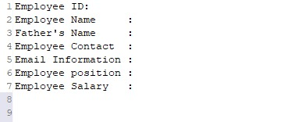

In an employee management system, the file.txt likely serves as a placeholder or example file name, and it doesn't have a standardized or inherent meaning in the context of such systems. The ".txt" extension typically denotes a plain text file, which can be used to store various types of information.

In an employee management system, files like "file.txt" could be used for purposes such as:

Data Storage: Storing employee data in a simple text format. Each line of the file could represent an employee record with relevant information like name, ID, position, etc.

Configuration: Storing configuration settings or parameters related to the employee management system. This could include things like system preferences, default settings, or rules.

Logs: Keeping a log of system activities, errors, or user interactions for debugging or auditing purposes. The file may contain a chronological record of events.

Import/Export: Acting as a simple data interchange format for importing or exporting employee data. This could be useful for data migration or integration with other systems.

It's important to note that the specific purpose and format of "file.txt" would depend on the design and requirements of the particular employee management system in question. If you have access to the system's documentation or source code, you should refer to that for a more precise understanding of the file's role.

55

**4. Testing Phase:**

Testing is a pivotal stage in SDLC, ensuring the software's functionality aligns with the specified requirements. It encompasses various testing methodologies, including unit testing, integration testing, and system testing. The goal is to identify and rectify defects, ensuring the software's reliability, performance, and security. Continuous and comprehensive testing throughout the development process is crucial for delivering a high-quality end product.[10]

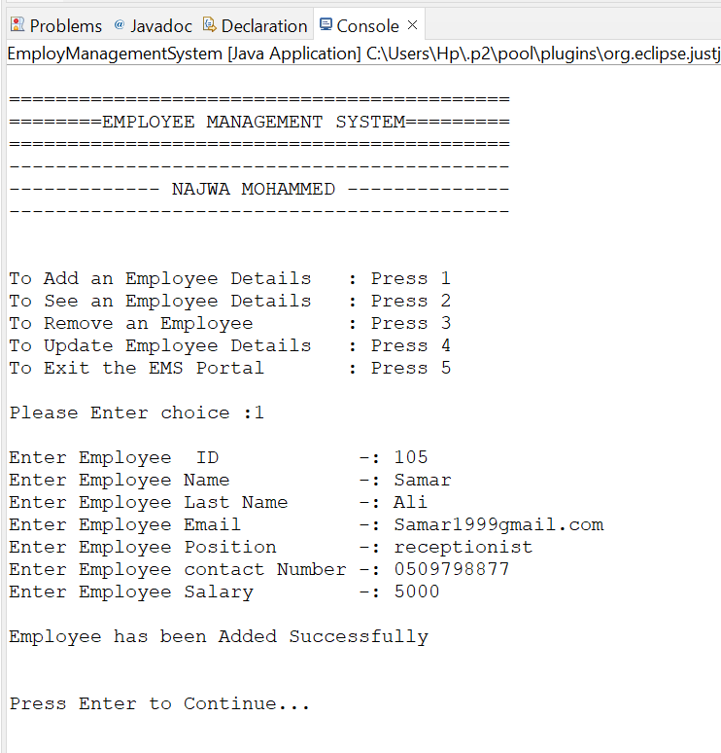

This is the result of the Employee_Detail class. All I did was choose the first option, which is number one, I pressed the enter button and added the new employee’s ID number and added his information.

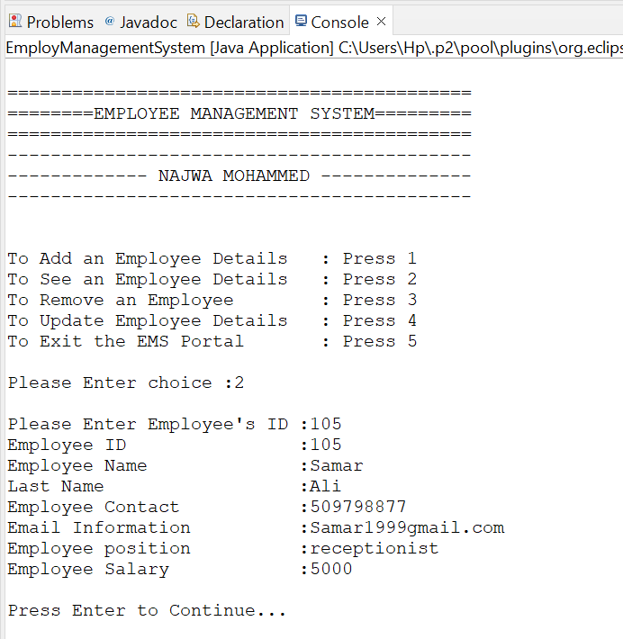

This is the result of the Show_Employee class. All I did was choose the second option which is number two and pressed the enter button, in the second option I was asked to enter the ID number of the employee whose information I want to see so I added the employee's ID number and all his information appeared to me.

56

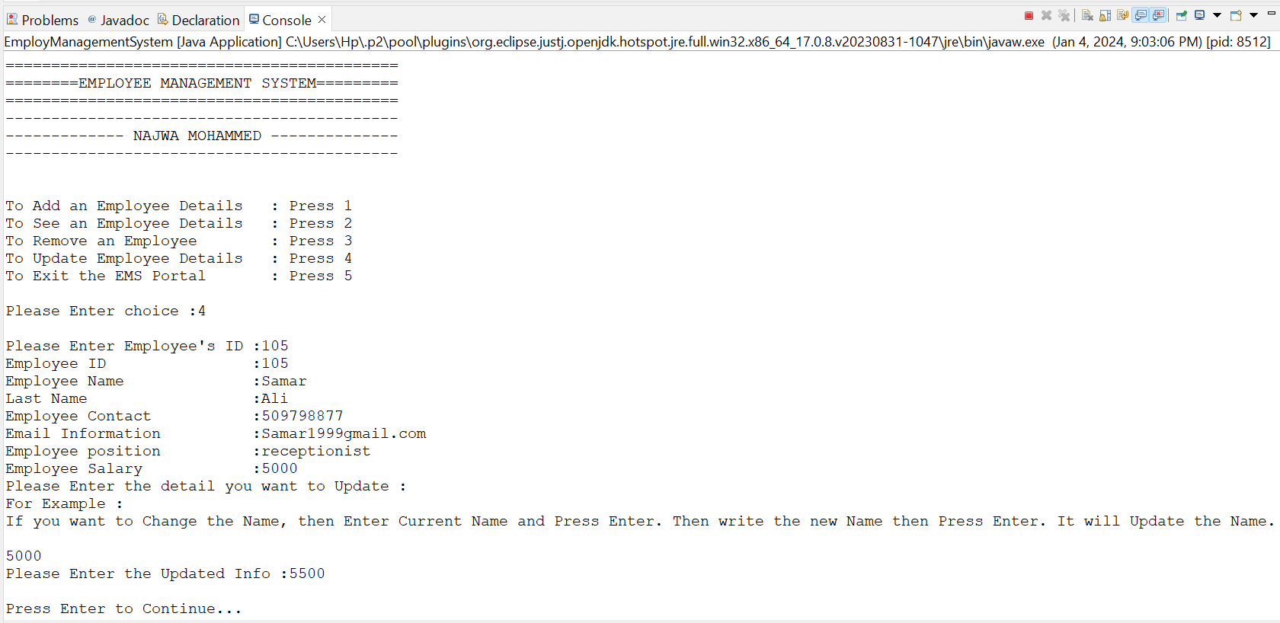

This is the result of the update class. All I did was choose the fourth option, which is the number four, and I pressed the enter button. In the fourth option, I was asked to enter the ID number of the employee whose information I wanted to update, so I added the employee’s ID number and all his information appeared to me, and then I was asked for the information I wanted to update. After that, I entered the updated information and then the Employee has been updated Successfully.

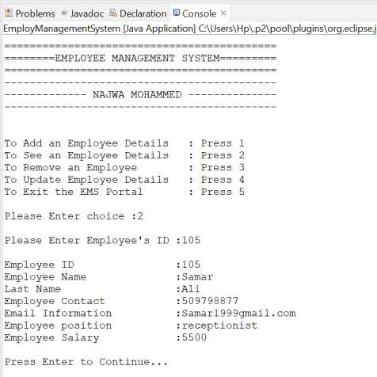 But the journey is not over yet in the update class. Let me tell you why? Because we have to check whether the information has been updated successfully or not. Here we will repeat the process of the Details class. When we return the method, we will see the employee’s details and we will find out if the information has been updated or not.

Let's check it out. I again chose the second option, which is the second number, and pressed the enter button. In the second option, I was again asked to enter the ID number of the employee whose information I want to see, so I added the employee's ID number and all his information appeared to me. The information has been updated successfully.

57

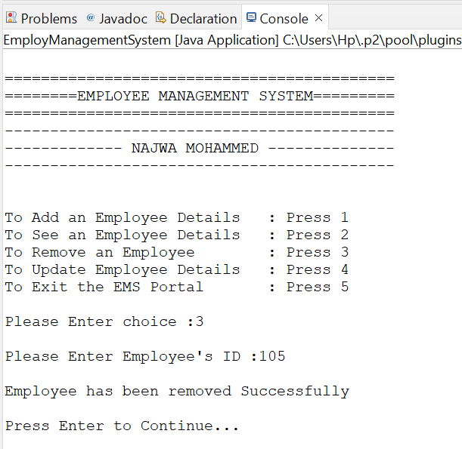

This is the result of the remove class. All I did was choose the third option which is number three and pressed the enter button, In the third option, I also be asked to enter the ID number of the employee whose information you want to remove, so I added the employee ID number and all his information removed.

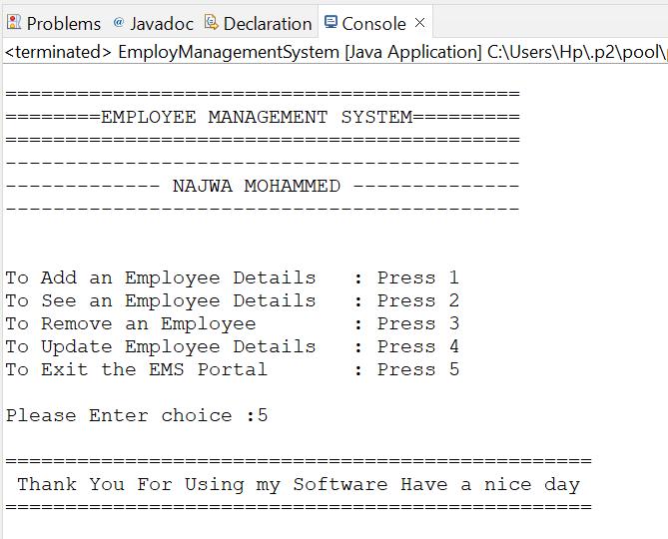

This is the result of the ExitCode class. All I did was choose the fifth option, which is number five, and pressed the enter button, and I exited the employee management system

58

**5. Deployment Phase:**

As the software reaches its final form, the deployment phase comes into play. This stage involves releasing the software for users. Careful planning is essential to ensure a smooth transition and minimal disruption during deployment. Post-deployment considerations, including ongoing support, monitoring, and feedback collection, become critical to address any issues promptly and optimize the software's performance in real-world scenarios.[10]

The stages of SDLC form a cohesive and systematic approach to software development. From the strategic planning phase to the meticulous design, the hands-on implementation, rigorous testing, and finally, the controlled deployment – each stage contributes to the overall success of the software development process. Understanding the nuances of each stage is paramount for software developers and project managers aiming to deliver high-quality, efficient, and user-friendly software products.[10]

**Diverse SDLC Models**

Understanding the various SDLC models is crucial for tailoring the development process to specific project requirements. Here are six notable models:[11]

**1. Waterfall Model**

The waterfall model represents a linear, sequential approach to SDLC, popular in software engineering and product development. Each phase must be completed before moving on to the next.[11]

**2. Agile Model**

Agile is an iterative development approach that breaks tasks into smaller iterations, promoting flexibility and adaptability throughout the project.[11]

**3. V-Shaped Model**

The V-shaped model, also known as Verification and Validation, executes in a sequential manner. Testing is associated with each corresponding development stage.[11]

59

**4. Iterative Model**

The iterative model involves repeating cycles of development and testing, refining the software with each iteration.[11]

**5. Spiral Model**

The spiral model combines elements of both linear and iterative models, allowing for flexibility and risk management.[11]

**6. Big Bang Model**

In the Big Bang model, development begins with minimal planning, making it suitable for small projects with undefined requirements.[11]

**Choosing the Right Methodology for You**

Determining the appropriate methodology is crucial for a successful software development journey. Factors such as project scope, flexibility, and planning play a pivotal role in this decision-making process.[11]

**Understanding the Need for SDLC**

SDLC models were introduced to bring discipline and systematic methods to software design. Breaking down the software development process into smaller parts makes problem-solving more manageable. Additionally:

* **Structured Process:** SDLC provides a step-by-step plan for designing, developing, testing, and maintaining software.
* **Problem Solving:** Breaking down the process into smaller parts makes complex problems more understandable and easier to solve.

In the dynamic world of software development, SDLC serves as a guiding compass. Whether you opt for the structured approach of the Waterfall model or the flexibility of Agile, understanding the stages and models is key to a successful software development journey.[11]

60

Integrated Development Environment (IDE)

In the ever-evolving world of programming, an Integrated Development Environment (IDE) stands out as an indispensable tool for developers

**Definition of IDE**

An Integrated Development Environment (IDE) is a comprehensive software suite that provides a unified platform for developers to write, test, and debug their code. It brings together essential tools, streamlining the entire development process.[12]

**Significance of IDE in the Programming World**

IDEs play a pivotal role in enhancing productivity, offering a one-stop solution for various tasks involved in software development. From coding to debugging and compiling, IDEs simplify the programmer's workflow.

**What is an IDE?**

An IDE is more than just a text editor; it's a powerhouse that combines multiple tools within a single interface. It typically includes a code editor, debugger, compiler, and other features tailored to facilitate efficient coding.[12]

**Importance of IDE**

The importance of an IDE lies in its ability to provide a seamless environment for programmers, fostering faster and more effective development. It acts as a virtual workspace, reducing the need for developers to switch between different applications.

**The Main Aim of an IDE**

The primary goal of an IDE is to enhance the developer's experience by offering a centralized platform that promotes collaboration, code organization, and ease of debugging.[12]

61

**Basic Features of an IDE**

1. **Text Editor**

An IDE's text editor is a robust tool that goes beyond basic code editing. It often includes features like syntax highlighting, auto-completion, and version control integration, making coding more efficient.

1. **Debugger**

The debugger is a crucial component for identifying and fixing errors in code. It allows developers to step through their code, inspect variables, and catch bugs before the final release.

1. **Compiler**

IDEs come equipped with compilers, translating the high-level code written by developers into machine-readable code. This feature ensures the code is executable and free from syntax errors.

1. **Programming Language Support**

IDEs support a wide array of programming languages, providing flexibility for developers working on diverse projects.

1. **Integrations and Plugins**

The ability to integrate with other tools and plugins extends an IDE's functionality. This ensures compatibility with various libraries, frameworks, and development methodologies.

**Life without Eclipse IDE**

**How Errors Are Detected Without Colors**

In a world without the visual cues of colors, error detection becomes a daunting task. Colors in IDEs signal different types of errors, aiding programmers in quickly identifying and rectifying issues.[12]

62

**Importance of Correction Feature in Programming**

One of the standout features of IDEs is their correction feature. This indispensable tool assists specialists in completing their work faster by suggesting improvements, fixing errors, and enhancing code quality.

**The Lack of Organization**

Without colors and suggestions, maintaining organization within a program becomes challenging. IDEs provide structure and guidance, helping programmers create clean and well-organized code.

**Advanced Text Editors IDE**

**Exploring Advanced Features**

While traditional text editors serve a purpose, advanced text editors with IDE features elevate the development experience. They often include intelligent code completion, real-time collaboration, and sophisticated debugging tools.

**A Comparison with Standard IDEs**

Comparing advanced text editors to standard IDEs sheds light on the trade-offs between simplicity and robust functionality. Developers must choose based on their specific needs and the complexity of their projects.

An Integrated Development Environment is the linchpin of modern software development. Its multifaceted approach, encompassing text editing, debugging, and compilation, makes it an indispensable companion for programmers. Embracing the features of an IDE not only improves efficiency but also elevates the overall quality of code.[12]

63

Debugging

Debugging is an indispensable aspect of software development, ensuring that codes run smoothly and efficiently. In this article, we'll delve into the intricacies of debugging, specifically focusing on the Java programming language*.*[13]

Debugging is akin to solving a puzzle, where developers identify and rectify errors in their code. It is a critical process in software development, enhancing the functionality and performance of programs.[13]

**Understanding the Debugging Process**

At its core, debugging is the process of identifying and fixing errors within a program. It involves a systematic approach to finding and resolving issues, ensuring the smooth execution of code. Debugging plays a pivotal role in code optimization, contributing to the overall success of software development projects.[13]

**Launching and Debugging a Java Program**

Launching a Java program involves a series of steps that set the stage for effective debugging. Developers must be familiar with the debugging process specific to Java to identify and resolve issues seamlessly.

**Unveiling Breakpoints**

Breakpoints act as markers in your code, allowing you to pause execution at specific points. Understanding the types and implementation of breakpoints is crucial for efficient debugging.[13]

64

**How to Create Breakpoints**

Creating breakpoints is a skill every developer should master. This section provides a step-by-step guide, ensuring developers can strategically place breakpoints for effective issue identification.[13]

**Conditional Breakpoints**

Conditional breakpoints add an extra layer of sophistication to debugging. Learn how to apply conditions to breakpoints, making the debugging process more dynamic and responsive.

**Navigating the Debugging Perspective**

The debugging perspective in Java offers a comprehensive view of your code during debugging. Understanding its components is vital for a seamless debugging experience.[13]

**Debugging Perspective Components**

* **Debug view**: Provides insights into the current state of the debugger.
* **Breakpoints view**: Displays all set breakpoints, enabling easy management.
* **Variables/Expression view**: Allows inspection of variables and expressions during debugging.
* **Display view**: Customizable view to display specific information during debugging.
* **Console view**: Shows program output and allows interaction with the program during debugging.

65

**Mastering Stepping Commands**

Stepping commands empower developers to navigate through code during debugging. This section explores the significance and application of various stepping commands.

**Understanding Trigger Points**

Trigger points serve as markers for specific conditions during debugging. Learn how to leverage trigger points to enhance your debugging process.

**Remote Debugging**

In a connected world, remote debugging is a valuable skill. Understand the nuances of setting up and executing remote debugging for efficient issue resolution.

**Challenges in Debugging**

Despite its significance, debugging comes with challenges. Identifying common issues and adopting strategies to overcome them is essential for developers.

debugging is not just about fixing errors; it's a mindset that leads to better code quality and more robust software. Embrace debugging as an integral part of your development journey for unparalleled success.[13]

66

Coding Standards

In the dynamic realm of software development, coding standards serve as the cornerstone. This article delves into the significance of coding standards, exploring why they matter, how they contribute to readable code, tools for enforcing and automating them, and common coding mistakes that can be avoided through adherence to these standards.[14]

**Understanding Coding Standards**

Coding standards are a set of guidelines and rules established to structure, format, and organize code consistently. They are not arbitrary; instead, they provide a framework that enhances collaboration, readability, and maintainability of code across a development team.[15]

**Why Coding Standards Matter**

In the coding universe, consistency is key. This section unravels the importance of coding standards, emphasizing their role in fostering a harmonized development environment and reducing the likelihood of errors.[15]

**How Coding Standards Contribute to Readable Code**

Readable code is not a luxury; it's a necessity. Here, we explore how adherence to coding standards contributes to the creation of code that is not only functional but also comprehensible, making the development process smoother and more efficient.

**Tools for Enforcing and Automating Coding Standards**

Ensuring that coding standards are followed can be challenging, but the right tools can make a significant difference. This section discusses various tools available to developers for enforcing and automating coding standards, streamlining the process and enhancing code quality.[15]

67

**Linters: The Guardians of Code Quality**

Linters are indispensable tools in the developer's toolkit. They analyze code for potential errors, stylistic inconsistencies, and adherence to coding standards. Learn about popular linters and how they contribute to maintaining a high standard of code.

**Integrated Development Environments (IDEs) and Coding Standards**

IDEs play a crucial role in the development workflow. Discover how modern IDEs support developers in adhering to coding standards seamlessly, providing real-time feedback and suggestions during the coding process.

**Common Coding Mistakes and Coding Standards**

Even the best developers can make mistakes, but coding standards act as a safety net. This section highlights common coding mistakes and demonstrates how adhering to coding standards can prevent these pitfalls, ensuring robust and error-free code.[15]

**The Pitfalls of Inconsistent Indentation**

Inconsistent indentation can lead to confusion and errors. Explore how coding standards address indentation issues and maintain code clarity.

**Variable Naming**

Effective variable naming is an art. Learn how coding standards guide developers in choosing meaningful and consistent names, promoting code that is self-explanatory and easy to understand.

**Conclusion**

As we conclude our exploration of coding standards, it's evident that they are not merely guidelines but the bedrock of robust, readable, and maintainable code. Embracing coding standards is a commitment to excellence in software development.

68

[1] “What is Algorithm | Introduction to Algorithms,” GeeksforGeeks. Accessed: Dec. 21, 2023. [Online]. Available: https://www.geeksforgeeks.org/introduction-to-algorithms/

[2] “What is Algorithm | Introduction to Algorithms,” GeeksforGeeks. Accessed: Dec. 26, 2023. [Online]. Available: https://www.geeksforgeeks.org/introduction-to-algorithms/

[3] S. Bhatt, “Characteristics of an Algorithm,” Medium. Accessed: Dec. 21, 2023. [Online]. Available: https://medium.com/@bhattshlok12/characteristics-of-an-algorithm-49cf4d7bcd9

[4] “What is a Flowchart,” Lucidchart. Accessed: Jan. 08, 2024. [Online]. Available: https://www.lucidchart.com/pages/what-is-a-flowchart-tutorial

[5] “Most important type of Algorithms,” GeeksforGeeks. Accessed: Jan. 08, 2024. [Online]. Available: https://www.geeksforgeeks.org/most-important-type-of-algorithms/

[6] A. Swain, “How the computer understands programming languages…,” Coffee with The UI Girl. Accessed: Jan. 08, 2024. [Online]. Available: https://medium.com/the-ui-girl/some-computer-science-questions-7c1056909757

[7] “Introduction of Programming Paradigms,” GeeksforGeeks. Accessed: Jan. 08, 2024. [Online]. Available: https://www.geeksforgeeks.org/introduction-of-programming-paradigms/

[8] “Differences between Procedural and Object Oriented Programming,” GeeksforGeeks. Accessed: Jan. 08, 2024. [Online]. Available: https://www.geeksforgeeks.org/differences-between-procedural-and-object-oriented-programming/

[9] “Software Development Life Cycle (SDLC),” GeeksforGeeks. Accessed: Jan. 08, 2024. [Online]. Available: https://www.geeksforgeeks.org/software-development-life-cycle-sdlc/

[10] T. P. Manager and H. Clark, “The Software Development Life Cycle (SDLC): 7 Phases and 5 Models,” The Product Manager. Accessed: Jan. 08, 2024. [Online]. Available: https://theproductmanager.com/topics/software-development-life-cycle/

[11] “6 effective SDLC models: Which one is best?” Accessed: Jan. 08, 2024. [Online]. Available: https://www.roberthalf.com/au/en/insights/management-tips/6-basic-sdlc-methodologies-which-one-best

[12] “What is integrated development environment (IDE)? | Definition from TechTarget,” Software Quality. Accessed: Jan. 08, 2024. [Online]. Available: https://www.techtarget.com/searchsoftwarequality/definition/integrated-development-environment

[13] “Debugging - Software Engineering,” GeeksforGeeks. Accessed: Jan. 08, 2024. [Online]. Available: https://www.geeksforgeeks.org/software-engineering-debugging/

[14] “Blog - Foundations of Software Development: A Comprehensive Guide.” Accessed: Jan. 08, 2024. [Online]. Available: https://www.sovtech.com/blog/foundations-of-software-development-a-comprehensive-guide

[15] “Coding Standards and Guidelines,” GeeksforGeeks. Accessed: Jan. 08, 2024. [Online]. Available: https://www.geeksforgeeks.org/coding-standards-and-guidelines/